**TABLE OF CONTENTS**

|  |  |  |
| --- | --- | --- |
| **SL.No** | **Topic** | **Page No** |
| **1**.  1.1  1.2  **2**  2.1  2.2  2.3  **3**  3.1  3.2  3.3  **4**  4.1  4.2  **5**  5.1  5.2  5.3  **6**  6.1  6.2  **7**  **8**  **9**  **10**  **11**  **12**  **13** | **Introduction**  Problem Definition Problem Description  **System Study**  Existing System  Proposed System  Feasibility Study  **System Diagram**  ER Diagram,  DFD [lev0, lev1]  Gantt Chart  **System Configuration**  Hardware Requirements Software Requirements  **Details of Software**  Overview of Frontend Overview of Backend About the Platform  **System Design**  Architectural Design Input / Output Design  **Testing Implementation**  **Conclusion and Future Enhancement Bibliography**  **APPENDICES A – Table Structure**  **APPENDICES B – Screenshots**  **Appendices C - Sample Report of test cases** | 2-3  3  3  4-6  5  5  5-6  7-16  8-12  13-15  16  17-18  18  18  19-24  20-21  21 -22  22-23  25-76  26  26-76  77-79  80-82  83-84  85-86  87-90  91-96  97-99 |

**CHAPTER 1**

**INTRODUCTION**

1. **INTRODUCTION**
   1. **Problem Definition**

Healthcare facilities encounter challenges in managing doctor appointments efficiently. Traditional appointment booking methods often involve manual processes, leading to delays, scheduling conflicts, and patient dissatisfaction. The need for a streamlined and user-friendly system to manage doctor appointments is crucial for improving patient experience and optimizing resource utilization in healthcare settings.

* 1. **Problem description**

The manual system for booking doctor appointments in healthcare facilities suffers from inefficiencies such as paperwork, errors, long wait times, and suboptimal resource allocation. Introducing a software solution would streamline appointment booking, enabling online scheduling, reducing administrative burden and errors, providing real-time updates for better schedule management, and centralizing patient records for improved data management. Overall, implementing such software would revolutionize healthcare operations, leading to smoother processes, shorter wait times, and better resource utilization.

**CHAPTER 2**

**SYSTEM STUDY**

1. **SYSTEM STUDY**
   1. **Existing System**

In our existing system, patients visiting the clinic must manually enter their details to schedule appointments, involving the completion of multiple forms. This manual process proves time-consuming and burdensome for patients. Moreover, depending on manual record-keeping escalates the likelihood of data entry errors and mismanagement.

* 1. **Proposed system**

This system greatly improves the appointment scheduling process, enhancing its efficiency and user-friendliness. It effectively tackles the problem of long waiting times by simplifying the booking procedure. Storing data in a database ensures its secure preservation, eliminating the risk of loss and enabling swift retrieval. This method reduces paperwork and simplifies the addition, deletion, and retrieval of data from the database, ensuring seamless accessibility and efficient management.

* 1. **Feasibility Study**

The basic idea behind feasibility study is to determine whether the project is feasible or not. Feasibility is conducted to identify a best system that meets all the requirements. This includes an identification, description, an evaluation of the proposed systems and selection of the best system for the job. The requirements of the system are specified with a set of constraints such as system objectives and the description of the out puts. It is then duty of the analyst to evaluate the feasibility of the proposed system to generate the above results. Three key factors are to be considered during the feasibility study.

### 2.3.1 Operational Feasibility

The software is developed with a focus on user-friendliness, utilizing VB.NET for the frontend to ensure easy navigation and data management. This section evaluates how the software will integrate into daily operations, the extent of training required for users, and the organization's readiness for adoption. The aim is to minimize operational disruptions and enhance efficiency through the software's implementation.

### 2.3.2 Technical Feasibility

The technical feasibility of the Nexamed Scheduler Software was rigorously evaluated, focusing on the organization's technological capabilities to support the system. This evaluation particularly considered performance, reliability, maintainability, and productivity. Choosing MySQL Workbench for the backend is pivotal for its superior data management features, ensuring the system's robustness and efficiency. A pre-development review of the organization's technological resources revealed adequate computing facilities and sophisticated hardware, affirming the project's technical viability with MySQL Workbench.

### 2.3.3 Economic Feasibility

Economic feasibility is critical in assessing the Nexamed Scheduler Software's viability, emphasizing the analysis's pivotal role in determining the project's financial soundness. This stage involves a detailed cost-benefit analysis, aimed at evaluating the economic implications of introducing the software within the organization's operations. The primary focus is on achieving a favorable balance between the investment needed for software development and deployment, and the anticipated operational efficiencies, cost savings, and enhanced client satisfaction. Given the organization's readiness in terms of necessary infrastructure, the project is anticipated to offer substantial economic benefits, affirming its financial feasibility.

**CHAPTER 3**

**SYSTEM DIAGRAM**

1. **ER DIAGRAM, DFD [LVL 0, LVL 1]**

### 3.1 ER Diagram:

The entity relationship model captures the essence of a database's structure by depicting real-world entities and their relationships. It provides a high-level overview of how different pieces of information are connected. This model is widely regarded as effective for designing databases because it closely mirrors the way we perceive and interact with data.

**Entity:**

An entity in the context of a database refers to a distinct object, concept, or thing about which data is stored. Entities can be tangible, such as a person, place, or thing, or they can be intangible, such as a concept or event. In database design, entities are typically represented as tables, with each row in the table corresponding to a specific instance or occurrence of that entity, and each column representing a particular attribute or characteristic of the entity.

For example, in a database for a company, entities might include "Employee," "Department," and "Project," with attributes such as employee ID, name, department name, etc. Entities are interconnected through relationships to form a coherent structure that accurately represents the real-world domain being modeled.

**Attributes:**

Entities are represented by means of their properties, called attributes. All attributes have values. For example, a student entity may have name, class, age as attributes. There exists a domain or range of values that can be assigned to attributes. For example, a student's name cannot be a numeric value. It has to be alphabetic. A student's age cannot be negative, etc.

An entity–relationship model (ER model) describes inter-related things of interest in a specific domain of knowledge. An ER model is composed of entity types (which classify the things of interest) and specifies relationships that can exist between instances of those entity types.

In [software engineering](https://en.wikipedia.org/wiki/Software_engineering) an ER model is commonly formed to represent things that a business needs to remember in order to perform business processes. Consequently, the ER model becomes an abstract [data model](https://en.wikipedia.org/wiki/Data_modeling) that defines a data or information structure that can be implemented in a [database](https://en.wikipedia.org/wiki/Database), typically a [relational database](https://en.wikipedia.org/wiki/Relational_database). Entity–relationship modeling was developed for database design by [Peter Chen](https://en.wikipedia.org/wiki/Peter_Chen) and published in a 1976 paper. However, variants of the idea existed previously, some ER modelers show super and subtype entities connected by generalization-specialization relationships, and an ER model can be used also in the specification of domain-specific ontology.

**3.1.1 Steps – How to Draw ER Diagram**

* Identify all the entities of the given problem
* Identify all the attributes of the entities identified in step 1.
* Identify the Primary Keys of entities identified in Step 1.
* Identify the Attribute Types of attributes identified in step 2
* Identify relationship between the entities and constraints on the entities and implement them.

**3.1.2 Entity Relationship Diagram Symbols and descriptions:**

|  |  |  |
| --- | --- | --- |
| **Symbol** | **Name** | **Description** |
| ERD Symbols and Meaning - Entity | Entity | An entity is represented by a rectangle which contains the entity’s name. |
| ERD Symbols and Meaning - Weak Entity | Weak entity | An entity that cannot be uniquely identified by its attributes alone. The existence of a weak entity is dependent upon another entity called the owner entity. The weak entity’s identifier is a combination of the identifier of the owner entity and the partial key of the weak entity. |
| ERD Symbols and Meaning - Associative Entity | Associative Entity | An entity used in a many-to- many relationship (represents an extra table). All relationships for the associative entity should be many |
| ERD Symbols and Meaning - Attribute | Attribute | In the Chen notation, each attribute is represented by an oval containing attribute’s name |

|  |  |  |
| --- | --- | --- |
| ERD Symbols and Meaning - Key attribute | Key Attribute | An attribute that uniquely identifies a particular entity. The name of a key attribute is underscored. |
| ERD Symbols and Meaning - Multivalue attribute | Multi-value Attribute | An attribute that can have many values (there are many distinct values entered for it in the same column of the table). Multi- valued attribute is depicted by a dual oval. |
| ERD Symbols and Meaning - Derived attribute | Derived Attribute | An attribute whose value is calculated (derived) from other attributes. The derived attribute may or may not be physically stored in the database. In the Chen notation, this attribute is represented by dashed oval. |
| ERD Symbols and Meaning - Relationship | Strong Relationship | A relationship where entity is existence-independent of other entities and PK of Child doesn’t contain PK component of Parent Entity. A strong relationship is represented by a  single rhombus |
| ERD Symbols and Meaning - Identifying Relationship | Weak Relationship | A relationship where Child entity is existence-dependent on parent and PK of Child Entity contains PK component of Parent Entity. This  relationship is represented by a double  rhombus. |

### 3.1.3 ER Diagram of Nexamed Scheduler:

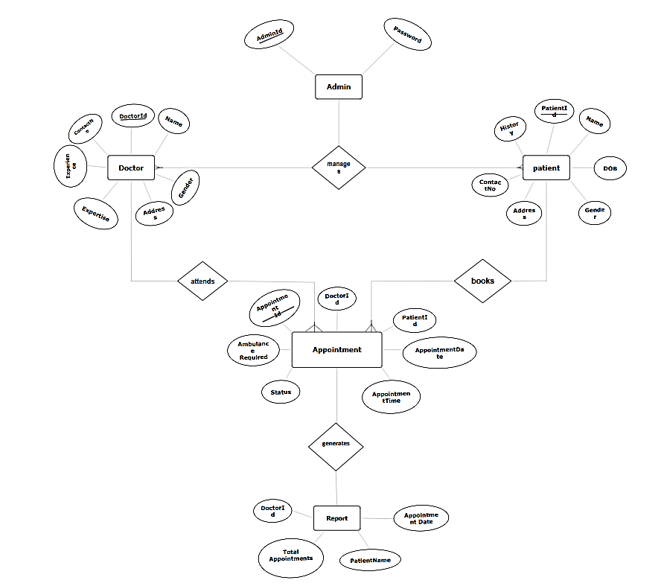

### 3.2 Data Flow Diagram

A data flow diagram (DFD) is a graphical representation of the "flow" of data through an information system, modelling its process aspects. A DFD is often used as a preliminary step to create an overview of the system, which can later be elaborated. DFDs can also be used for the visualization of data processing (structured design).

A DFD shows what kind of information will be input to and output from the system, where the data will come from and go to, and where the data will be stored. It does not show information about the timing of process or information about whether processes will operate in sequence or in parallel (which is shown on a flowchart).

A DFD shows what kind of information will be input to and output from the system, where the data will come from and go to, and where the data will be stored. It does not show information about the timing of process or information about whether processes will operate in sequence or in parallel.

It is common practice to draw the [context-level data flow diagram](http://en.wikipedia.org/wiki/System_context_diagram) first, which shows the interaction between the system and external agents which act as data sources and data sinks. This helps to create an accurate drawing in the context diagram. The system's interactions with the outside world are modelled purely in terms of data flows across the system boundary. The context diagram shows the entire system as a single process, and gives no clues as to its internal organization.

**3.2.1 DFD Symbols and Meanings:**

|  |  |  |
| --- | --- | --- |
| **Symbol** | **Meaning** | **Example** |
|  | An entity. A source of data  or a destination for data. | Patient |
|  | A process or task that is performed by the system. | Cancellation |
|  | A data store, a place where data is held between processes. |  |
|  | A data flow | Cancel |

**3.2.2 DFD Level 0:**

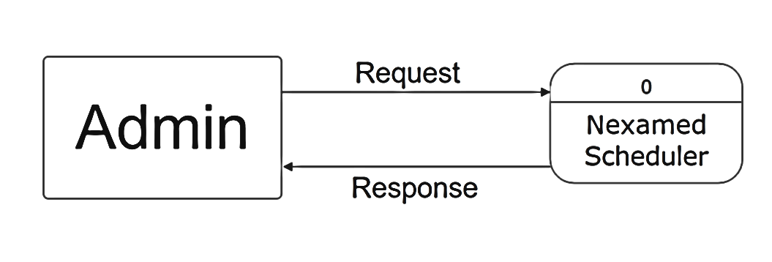

2

**3.2.2 DFD Level 1:**

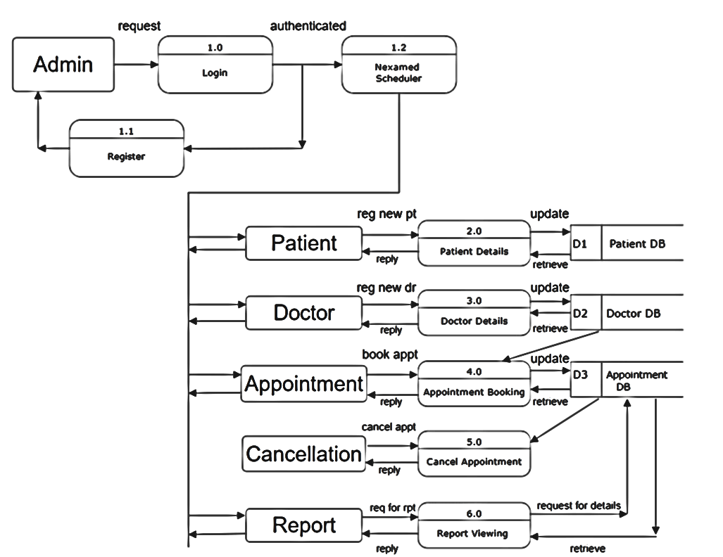

### 3.3 Gantt Chart

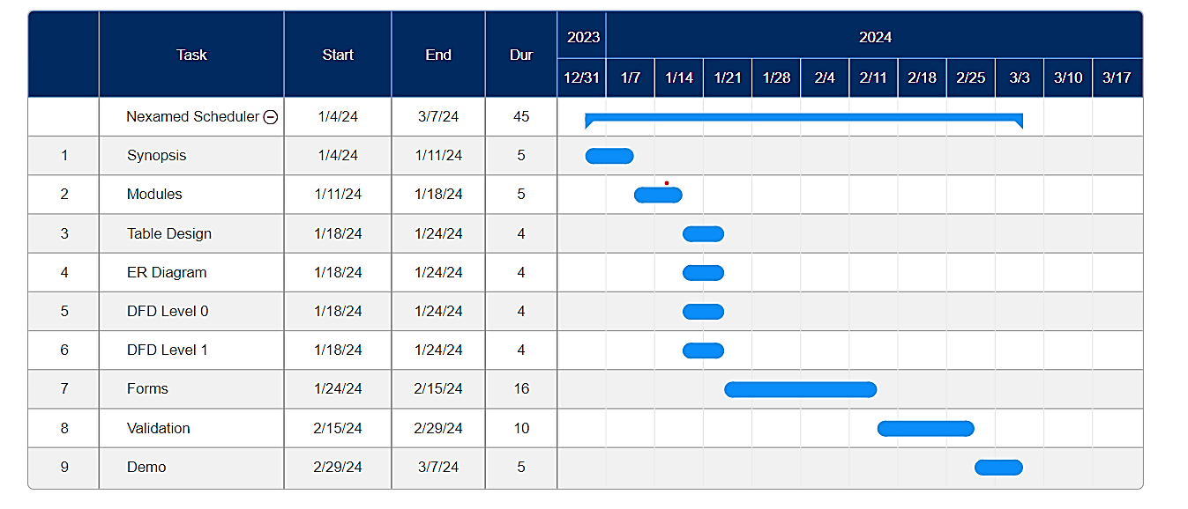

**CHAPTER 4**

**SYSTEM**

**CONFIGURATION**

**4. SYSTEM CONFIGURATION**

**4.1 HARDWARE REQUIREMENTS**

|  |  |
| --- | --- |
| **Processor** | Intel core i3 or above |
| **Clock speed** | 3.00Ghz |
| **Ram** | 4gb or more |
| **HDD** | 50gb |
| **Monitor** | SVGA color |
| **Key board** | 101 keys |
| **Mouse** | ps2/ serial |

**4.2 SOFTWARE REQUIREMENTS**

|  |  |
| --- | --- |
| **Operating System** | Windows 11 |
| **Programming Language** | VB.NET |
| **Database** | SQL Workbench 8.0 CE |
| **Tool** | Visual Studio 2022 |

**CHAPTER 5**

**DETAILS OF SOFTWARE**

**5. DETAILS OF SOFTWARE**

**5.1 Overview of Frontend**

Introduction To the .Net Framework:

The .NET Framework is a new computing platform that simplifies application development in the highly distributed environment of the Internet. The .NET Framework is designed to fulfil the following objectives:

* To provide a consistent object-oriented programming environment whether object code is stored and executed locally, executed locally but Internet-distributed, or executed remotely.
* To provide a code-execution environment that minimizes software deployment and versioning conflicts.
* To provide a code-execution environment that guarantees safe execution of code, including code created by an unknown or semi-trusted third party.
* To provide a code-execution environment that eliminates the performance problems of scripted or interpreted environments.
* To make the developer experience consistent across widely varying types of applications, such as Windows-based applications and Web-based applications.
* To build all communication on industry standards to ensure that code based on the

.NET Framework can integrate with any other code.

The .NET Framework has two main components: the common language runtime and the .NET Framework class library. The common language runtime is the foundation of the .NET Framework. You can think of the runtime as an agent that manages code at execution time, providing core services such as memory management, thread management while also enforcing strict type safety and other forms of code accuracy that ensure security and robustness. In fact, the concept of code management is a fundamental principle of the runtime. Code that targets the runtime is known as managed code, while code that does not target the runtime is known as unmanaged code. The class library, the other main component of the .NET Framework, is a comprehensive, object-oriented collection of reusable types that you can use to develop applications ranging

**5.2 Overview of Backend**

**5.2.1 MySQL Workbench**

A Database Management System (DBMS) like MySQL Workbench empowers users to manage their data effectively, facilitating the transformation of raw data into meaningful information. Alongside dBase, Paradox, and others, MySQL Workbench stands as a powerful tool in this realm, enabling users to create, update, and retrieve information from their databases seamlessly.

In MySQL Workbench, data is organized into a structured collection within tables. Each piece of data, representing attributes of people, objects, or events, resides within designated fields. These fields collectively form records, each representing a complete unit of data pertaining to a specific entity. Throughout the database design process, careful analysis of business requirements guides the identification of relevant fields or attributes. Should business needs evolve, MySQL Workbench allows for the addition of new fields or modifications to existing ones to accommodate changes seamlessly.

In project reports, highlighting the versatility and scalability of MySQL Workbench in adapting to evolving business needs can be highly valuable. Additionally, emphasizing its user-friendly interface, robust features for data modeling, querying, and administration, as well as its compatibility with various operating systems, can further underscore its significance in database management and development projects. Moreover, discussing specific functionalities within MySQL Workbench, such as its schema design tools, query optimization capabilities, and data visualization options, can provide insights into its practical applications and benefits within the project context.

**5.2.2 MySQL Tables:**

In MySQL Workbench, data records are organized within tables, with each table containing related information. These tables collectively form a database, grouping together related sets of data.

**5.2.3 Primary key:**

Similar to SQL Server, each table in MySQL Workbench possesses a field or a combination of fields that uniquely identifies each record within the table. This unique identifier is termed the Primary Key. It serves as a crucial means to distinguish individual records, enabling users and the database system to locate, identify, and refer to specific records within the database.

**5.2.4 Relational database:**

MySQL Workbench facilitates the creation of relational databases, allowing for the storage of data across multiple tables. This relational approach enables efficient management of complex datasets and simplifies data organization. For instance, MySQL Workbench easily facilitates linking employees to their respective departments, exemplifying its capability as a Relational Database Management System (RDBMS).

**5.2.5 Foreign key:**

When a field within one table that matches the primary key of another table is termed a foreign key. Foreign keys establish relationships between tables, linking data across different entities within the database.

### 5.2.6 Referential integrity:

MySQL Workbench ensures referential integrity by maintaining consistency among related tables. This entails ensuring that data between linked tables remains accurately matched, preventing inconsistencies and preserving data integrity.

**5.3 About the platform:**

MySQL Workbench stands as a leading database management system, renowned for its versatility, performance, and capability to meet the diverse needs of modern information systems. From handling complex decision support systems to rigorous online transaction processing applications, MySQL Workbench excels in performance and functionality.

Key Features of MySQL Workbench include:

* Internet Integration: MySQL Workbench seamlessly integrates with web applications, offering robust support for XML and scalability features, ensuring efficient operation in web environments.
* Scalability and Availability: MySQL Workbench supports scalability across various platforms, from laptops to large servers. Its Enterprise Edition boasts features such as federated servers and large memory support, enabling it to scale to meet the demands of high-traffic websites.
* Replication: MySQL Workbench offers support for various replication types, including merge, transactional, and snapshot replication, facilitating data synchronization across heterogeneous systems.
* Enterprise-Level Database Features: MySQL Workbench's relational database engine provides comprehensive features to support demanding data processing environments. These features include distributed queries, replication, and distributed transaction support, ensuring data integrity and efficient management of concurrent user modifications.

**System Maintenance and Evaluation:**

System maintenance is the process of modifying software product after it is delivered to the customer. Software maintenance is inevitable as it is subjected to wear and tear.

* It is necessary to rectify some errors in the system or increase the performance of the system. This is done by corrective maintenance.
* If the customer demand that their product has to run on new platform then adoptive maintenance is required. It is also applied when the system has to interface with new hardware or software.
* It helps to support new system features. The users can change different functions of the system.

The project is developed using the Water fall model. It suggests the systematic and sequential approach to software development. Waterfall model is the oldest and most widely used process model. Each phase of the life cycle is completed before the start of a new phase. It is the engineering approach. The waterfall model makes the project:

* Simple in nature.
* Easy to implement.
* Systematic Approach.
* It is an essential approach to software development.

**CHAPTER 6**

**SYSTEM DESIGN**

**6. SYSTEM DESIGN**

### 6.1 Architectural Design:

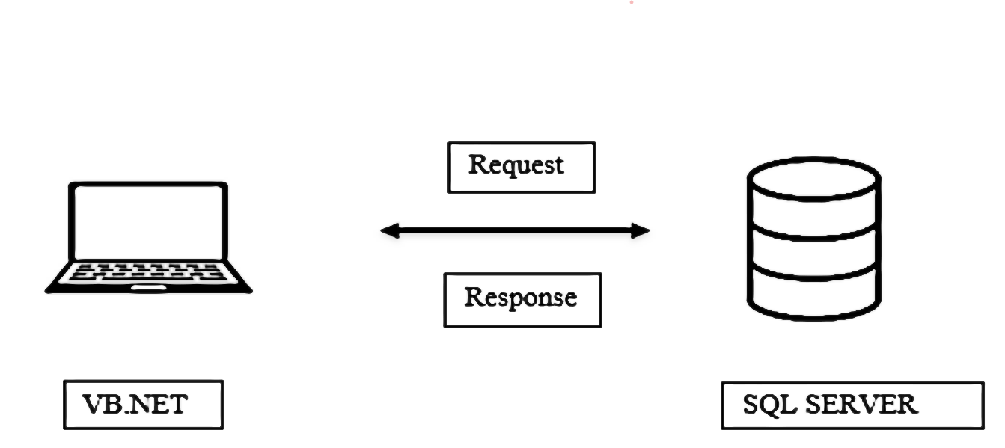

**6.2 INPUT /OUTPUT DESIGN:**

The design of input focuses on controlling the amount of input required, controlling the errors, avoiding delay, avoiding extra steps and keeping the process simple. The input is designed in such a way so that it provides security and ease of use with retaining the privacy.

**6.2.1 INPUT DESIGN:**

Input Design is the process of converting a user-oriented description of the input into a computer-based system. This design is important to avoid errors in the data input process and show the correct direction to the management for getting correct information from the computerized system.

It is achieved by creating user-friendly screens for the data entry to handle large volume of data. The goal of designing input is to make data entry easier and to be free from errors. The data entry screen is designed in such a way that all the data manipulates can be performed. It also provides record viewing facilities. When the data is entered it will check for its validity. Data can be entered with the help of screens. Appropriate messages are provided as when needed so that the user will not be in a maize of instant. Thus the objective of input design is to create an input layout that is easy to follow.

Below are VB.net codes used in the development of the project:

### Admin-Login Page:

Imports MySql.Data.MySqlClient

Public Class Form1

Private Sub Button1_Click(sender As Object, e As EventArgs) Handles Button1.Click

If String.IsNullOrWhiteSpace(TextBox1.Text) OrElse String.IsNullOrWhiteSpace(TextBox2.Text) Then

MessageBox.Show("Please enter both username and password.", "Validation Error", MessageBoxButtons.OK, MessageBoxIcon.Error)

Return

End If

Try

Using conn As New MySqlConnection("Data Source=localhost;database=nexamed;username=root;password=pass")

conn.Open()

Dim cmd As New MySqlCommand("select * from admin where Adminid=@id AND Password=@password", conn)

cmd.Parameters.AddWithValue("id", TextBox1.Text.Trim)

cmd.Parameters.AddWithValue("password", TextBox2.Text.Trim)

Dim reader As MySqlDataReader = cmd.ExecuteReader

If reader.Read Then

Form2.Show()

Me.Hide()

Else

MessageBox.Show("Invalid username or password. Please try again.", "Authentication Failed", MessageBoxButtons.OK, MessageBoxIcon.Error)

TextBox2.Text = ""

End If

End Using

Catch ex As Exception

MessageBox.Show("An error occurred: " & ex.Message, "Error", MessageBoxButtons.OK, MessageBoxIcon.Error)

End Try

End Sub

Private Sub CheckBox2_CheckedChanged(sender As Object, e As EventArgs) Handles CheckBox2.CheckedChanged

If CheckBox2.Checked = True Then

TextBox2.PasswordChar = ""

Else

TextBox2.PasswordChar = "*"

End If

End Sub

Private Sub TextBox1_KeyPress(sender As Object, e As KeyPressEventArgs) Handles TextBox1.KeyPress

' Check if the entered key is a digit or backspace

If Not Char.IsDigit(e.KeyChar) And e.KeyChar <> Convert.ToChar(Keys.Back) Then

e.Handled = True ' Ignore the key input if it is not a digit or backspace

MessageBox.Show("AdminId must be a valid integer.", "Validation Error", MessageBoxButtons.OK, MessageBoxIcon.Error)

End If

End Sub

Private Sub Button2_Click(sender As Object, e As EventArgs) Handles Button2.Click

TextBox1.Text = ""

TextBox2.Text = ""

End Sub

Private Sub Label5_Click(sender As Object, e As EventArgs) Handles Label5.Click

Register.Show()

Me.Hide()

End Sub

End Class

### Doctor Page:

Imports MySql.Data.MySqlClient

Public Class doctor

Dim conn As New MySqlConnection("Data Source=localhost;database=nexamed;username=root;password=pass")

Private Sub doctor_Load(sender As Object, e As EventArgs) Handles MyBase.Load

LoadDataIntoDataGridView()

End Sub

Private Sub Button1_Click(sender As Object, e As EventArgs) Handles Button1.Click

' Validate input fields before saving

If String.IsNullOrWhiteSpace(TextBox1.Text) OrElse

Not IsNumeric(TextBox1.Text) OrElse

String.IsNullOrWhiteSpace(TextBox2.Text) OrElse

ContainsNumeric(TextBox2.Text) OrElse

(Not RadioButton1.Checked AndAlso Not RadioButton2.Checked) OrElse

String.IsNullOrWhiteSpace(TextBox3.Text) OrElse

String.IsNullOrWhiteSpace(TextBox4.Text) OrElse

String.IsNullOrWhiteSpace(TextBox5.Text) OrElse

Not IsNumeric(TextBox5.Text) OrElse

String.IsNullOrWhiteSpace(TextBox6.Text) OrElse

Not IsNumeric(TextBox6.Text) OrElse

TextBox6.Text.Length <> 10 Then

MessageBox.Show("Please fill all fields correctly.", "Validation Error", MessageBoxButtons.OK, MessageBoxIcon.Error)

Return

End If

Try

If conn.State = ConnectionState.Closed Then

conn.Open()

End If

Dim doctorId As Integer

Dim name As String = TextBox2.Text

Dim gender As String = If(RadioButton1.Checked, "Male", "Female")

Dim address As String = TextBox3.Text

Dim expertise As String = TextBox4.Text

Dim experience As Integer

Dim contactNo As String = TextBox6.Text

' Validate if the entered values are valid

If Integer.TryParse(TextBox1.Text, doctorId) AndAlso

Integer.TryParse(TextBox5.Text, experience) Then

' Check if name, address, and expertise are not empty

If Not String.IsNullOrEmpty(name) AndAlso

Not String.IsNullOrEmpty(address) AndAlso

Not String.IsNullOrEmpty(expertise) Then

' Check for duplicate key before executing the query

If Not IsDuplicateKey(doctorId) Then

Dim insertQuery As String = "INSERT INTO doctor (doctorid, name, gender, address, expertise, experience, contactno) VALUES (@DoctorId, @Name, @Gender, @Address, @Expertise, @Experience, @ContactNo)"

Using cmd As New MySqlCommand(insertQuery, conn)

cmd.Parameters.AddWithValue("@DoctorId", doctorId)

cmd.Parameters.AddWithValue("@Name", name)

cmd.Parameters.AddWithValue("@Gender", gender)

cmd.Parameters.AddWithValue("@Address", address)

cmd.Parameters.AddWithValue("@Expertise", expertise)

cmd.Parameters.AddWithValue("@Experience", experience)

cmd.Parameters.AddWithValue("@ContactNo", contactNo)

cmd.ExecuteNonQuery()

MessageBox.Show("Record added successfully.", "Success", MessageBoxButtons.OK, MessageBoxIcon.Information)

' Load data into DataGridView

LoadDataIntoDataGridView()

ClearTextBoxes()

End Using

Else

MessageBox.Show("DoctorId already present. Please enter a different DoctorId.", "Duplicate Key Error", MessageBoxButtons.OK, MessageBoxIcon.Error)

End If

Else

MessageBox.Show("Name, Address, and Expertise cannot be empty.", "Validation Error", MessageBoxButtons.OK, MessageBoxIcon.Error)

End If

Else

MessageBox.Show("Invalid input for DoctorId, Experience, or ContactNo.", "Validation Error", MessageBoxButtons.OK, MessageBoxIcon.Error)

End If

Catch ex As Exception

MessageBox.Show("Error: " & ex.Message, "Error", MessageBoxButtons.OK, MessageBoxIcon.Error)

Finally

If conn.State = ConnectionState.Open Then

conn.Close()

End If

End Try

End Sub

Private Function IsDuplicateKey(doctorId As Integer) As Boolean

' Check if the DoctorId already exists in the database

Dim query As String = "SELECT COUNT(*) FROM doctor WHERE doctorid = @DoctorId"

Using cmd As New MySqlCommand(query, conn)

cmd.Parameters.AddWithValue("@DoctorId", doctorId)

Dim count As Integer = CInt(cmd.ExecuteScalar())

Return count > 0

End Using

End Function

Private Sub Button2_Click(sender As Object, e As EventArgs) Handles Button2.Click

Try

If conn.State = ConnectionState.Closed Then

conn.Open()

End If

Dim selectedRowIndex As Integer = DataGridView1.CurrentCell.RowIndex

If selectedRowIndex >= 0 Then

Dim doctorId As Integer

Dim name As String = TextBox2.Text

Dim gender As String = If(RadioButton1.Checked, "Male", "Female")

Dim address As String = TextBox3.Text

Dim expertise As String = TextBox4.Text

Dim experience As Integer

Dim contactNo As String = TextBox6.Text

' Validate if the entered values are valid

If Integer.TryParse(TextBox1.Text, doctorId) AndAlso

Integer.TryParse(TextBox5.Text, experience) Then

' Check if name, address, and expertise are not empty

If Not String.IsNullOrEmpty(name) AndAlso

Not String.IsNullOrEmpty(address) AndAlso

Not String.IsNullOrEmpty(expertise) Then

Dim updateQuery As String = "UPDATE doctor SET name = @Name, gender = @Gender, address = @Address, expertise = @Expertise, experience = @Experience, contactno = @ContactNo WHERE doctorid = @DoctorId"

Using cmd As New MySqlCommand(updateQuery, conn)

cmd.Parameters.AddWithValue("@DoctorId", doctorId)

cmd.Parameters.AddWithValue("@Name", name)

cmd.Parameters.AddWithValue("@Gender", gender)

cmd.Parameters.AddWithValue("@Address", address)

cmd.Parameters.AddWithValue("@Expertise", expertise)

cmd.Parameters.AddWithValue("@Experience", experience)

cmd.Parameters.AddWithValue("@ContactNo", contactNo)

cmd.ExecuteNonQuery()

MessageBox.Show("Record updated successfully.", "Success", MessageBoxButtons.OK, MessageBoxIcon.Information)

End Using

' Load data into DataGridView

LoadDataIntoDataGridView()

ClearTextBoxes()

Else

MessageBox.Show("Name, Address, and Expertise cannot be empty.")

End If

Else

MessageBox.Show("Invalid input for DoctorId, Experience, or ContactNo.")

End If

Else

MessageBox.Show("Please select a row to update.")

End If

Catch ex As Exception

MessageBox.Show("Error: " & ex.Message)

Finally

If conn.State = ConnectionState.Open Then

conn.Close()

End If

End Try

End Sub

Private Sub Button3_Click(sender As Object, e As EventArgs) Handles Button3.Click

Try

If conn.State = ConnectionState.Closed Then

conn.Open()

End If

Dim selectedRowIndex As Integer = DataGridView1.CurrentCell.RowIndex

If selectedRowIndex >= 0 Then

Dim doctorId As Integer = Convert.ToInt32(TextBox1.Text)

' Check if DoctorId is not empty

If doctorId > 0 Then

Dim confirmResult As DialogResult = MessageBox.Show("Are you sure you want to delete this record?",

"Confirm Delete",

MessageBoxButtons.YesNo,

MessageBoxIcon.Question)

If confirmResult = DialogResult.Yes Then

Dim deleteQuery As String = "DELETE FROM doctor WHERE doctorid = @DoctorId"

Using cmd As New MySqlCommand(deleteQuery, conn)

cmd.Parameters.AddWithValue("@DoctorId", doctorId)

cmd.ExecuteNonQuery()

MessageBox.Show("Record deleted successfully.", "Success", MessageBoxButtons.OK, MessageBoxIcon.Information)

End Using

' Load data into DataGridView

LoadDataIntoDataGridView()

ClearTextBoxes()

End If

Else

MessageBox.Show("DoctorId cannot be empty.")

End If

Else

MessageBox.Show("Please select a row to delete.")

End If

Catch ex As Exception

MessageBox.Show("Error: " & ex.Message)

Finally

If conn.State = ConnectionState.Open Then

conn.Close()

End If

End Try

End Sub

' Load data into DataGridView from the database

Private Sub LoadDataIntoDataGridView()

Try

If conn.State = ConnectionState.Closed Then

conn.Open()

End If

Dim selectQuery As String = "SELECT * FROM doctor"

Using cmd As New MySqlCommand(selectQuery, conn)

Using adapter As New MySqlDataAdapter(cmd)

Dim dataTable As New DataTable()

adapter.Fill(dataTable)

DataGridView1.DataSource = dataTable

End Using

End Using

Catch ex As Exception

MessageBox.Show("Error: " & ex.Message)

Finally

If conn.State = ConnectionState.Open Then

conn.Close()

End If

End Try

End Sub

' Clear TextBoxes

Private Sub ClearTextBoxes()

TextBox1.Clear()

TextBox2.Clear()

TextBox3.Clear()

TextBox4.Clear()

TextBox5.Clear()

TextBox6.Clear()

RadioButton1.Checked = False

RadioButton2.Checked = False

End Sub

Private Sub Button4_Click(sender As Object, e As EventArgs) Handles Button4.Click

ClearTextBoxes()

End Sub

Private Sub DataGridView1_CellClick(sender As Object, e As DataGridViewCellEventArgs) Handles DataGridView1.CellClick

If e.RowIndex >= 0 Then

Dim row As DataGridViewRow = DataGridView1.Rows(e.RowIndex)

TextBox1.Text = row.Cells("doctorid").Value.ToString()

TextBox2.Text = row.Cells("name").Value.ToString()

Dim gender As String = row.Cells("gender").Value.ToString()

If gender = "Male" Then

RadioButton1.Checked = True

ElseIf gender = "Female" Then

RadioButton2.Checked = True

End If

TextBox3.Text = row.Cells("address").Value.ToString()

TextBox4.Text = row.Cells("expertise").Value.ToString()

TextBox5.Text = row.Cells("experience").Value.ToString()

TextBox6.Text = row.Cells("contactno").Value.ToString()

End If

End Sub

Private Sub TextBox1_KeyPress(sender As Object, e As KeyPressEventArgs) Handles TextBox1.KeyPress

' Check if the entered key is not a digit or backspace

If Not Char.IsDigit(e.KeyChar) AndAlso e.KeyChar <> Convert.ToChar(Keys.Back) Then

e.Handled = True ' Ignore the key input if it is not a digit or backspace

MessageBox.Show("Doctor ID must be a numeric value.", "Validation Error", MessageBoxButtons.OK, MessageBoxIcon.Error)

End If

End Sub

Private Sub TextBox2_KeyPress(sender As Object, e As KeyPressEventArgs) Handles

TextBox2.KeyPress

' Allow letters, spaces, and backspace

If Not Char.IsLetter(e.KeyChar) AndAlso e.KeyChar <> Convert.ToChar(Keys.Back) AndAlso e.KeyChar <> " "c Then

e.Handled = True ' Ignore the key input if it is not a letter, space, or backspace

MessageBox.Show("Name must contain only alphabet characters.", "Validation Error",

MessageBoxButtons.OK, MessageBoxIcon.Error)

End If

End Sub

Private Sub TextBox4_KeyPress(sender As Object, e As KeyPressEventArgs) Handles TextBox4.KeyPress

' Allow letters, spaces, and backspace

If Not Char.IsLetter(e.KeyChar) AndAlso e.KeyChar <> Convert.ToChar(Keys.Back) AndAlso e.KeyChar <> " "c Then

e.Handled = True ' Ignore the key input if it is not a letter, space, or backspace

MessageBox.Show("Expertise must contain only alphabet characters.", "Validation Error", MessageBoxButtons.OK, MessageBoxIcon.Error)

End If

End Sub

Private Sub TextBox5_KeyPress(sender As Object, e As KeyPressEventArgs) Handles TextBox5.KeyPress

' Check if the entered key is not a digit or backspace

If Not Char.IsDigit(e.KeyChar) AndAlso e.KeyChar <> Convert.ToChar(Keys.Back) Then

e.Handled = True ' Ignore the key input if it is not a digit or backspace

MessageBox.Show("Experience must be a numeric value.", "Validation Error", MessageBoxButtons.OK, MessageBoxIcon.Error)

End If

End Sub

Private Sub TextBox6_KeyPress(sender As Object, e As KeyPressEventArgs) Handles TextBox6.KeyPress

' Check if the entered key is not a digit or backspace

If Not Char.IsDigit(e.KeyChar) AndAlso e.KeyChar <> Convert.ToChar(Keys.Back) Then

e.Handled = True ' Ignore the key input if it is not a digit or backspace

MessageBox.Show("Contact number must be a numeric value.", "Validation Error", MessageBoxButtons.OK, MessageBoxIcon.Error)

End If

' Check if the length of TextBox6 is already 10 (considering 0-based index)

If TextBox6.Text.Length >= 10 And e.KeyChar <> Convert.ToChar(Keys.Back) Then

e.Handled = True ' Ignore the key input if it would exceed 10 digits

MessageBox.Show("Contact number must be a 10-digit integer.", "Validation Error", MessageBoxButtons.OK, MessageBoxIcon.Error)

End If

End Sub

Private Function ContainsNumeric(value As String) As Boolean

For Each c As Char In value

If Char.IsDigit(c) Then

Return True

End If

Next

Return False

End Function

Private Sub Label2_Click(sender As Object, e As EventArgs) Handles Label2.Click

Form3.Show()

Me.Hide()

End Sub

Private Sub Label3_Click(sender As Object, e As EventArgs) Handles Label3.Click

patient.Show()

Me.Hide()

End Sub

Private Sub PictureBox3_Click(sender As Object, e As EventArgs) Handles PictureBox3.Click

Form3.Show()

Me.Hide()

End Sub

Private Sub PictureBox4_Click(sender As Object, e As EventArgs) Handles PictureBox4.Click

Form3.Show()

Me.Hide()

End Sub

Private Sub PictureBox2_Click_1(sender As Object, e As EventArgs) Handles PictureBox2.Click

Form2.Show()

Me.Hide()

End Sub

End Class

### Appointment Page:

Imports MySql.Data.MySqlClient

Public Class form4

Dim conn As New MySqlConnection("Data Source=localhost;database=nexamed;username=root;password=pass")

Private Sub BookingForm_Load(sender As Object, e As EventArgs) Handles MyBase.Load

' Populate ComboBox1 with distinct doctor expertise

PopulateDoctorExpertiseComboBox()

PopulateTimeSlotsComboBox()

' Update the DataGridView when the form loads

UpdateDataGridView()

End Sub

Private Sub PopulateDoctorExpertiseComboBox()

' Populate ComboBox1 with distinct doctor expertise from the Doctor table

Dim query As String = "SELECT DISTINCT Expertise FROM Doctor"

Using connection As New MySqlConnection(conn.ConnectionString)

Using command As New MySqlCommand(query, connection)

connection.Open()

Dim reader As MySqlDataReader = command.ExecuteReader()

While reader.Read()

ComboBox1.Items.Add(reader.GetString("Expertise"))

End While

End Using

End Using

End Sub

Private Sub PopulateTimeSlotsComboBox()

' Add predefined time slots to ComboBox3

ComboBox3.Items.Clear() ' Clear existing items first

ComboBox3.Items.Add("08:00 AM")

ComboBox3.Items.Add("08:15 AM")

ComboBox3.Items.Add("08:30 AM")

ComboBox3.Items.Add("08:45 AM")

ComboBox3.Items.Add("09:00 AM")

ComboBox3.Items.Add("09:15 AM")

ComboBox3.Items.Add("09:30 AM")

ComboBox3.Items.Add("09:45 AM")

ComboBox3.Items.Add("10:00 AM")

ComboBox3.Items.Add("10:15 AM")

ComboBox3.Items.Add("10:30 AM")

ComboBox3.Items.Add("10:45 AM")

ComboBox3.Items.Add("11:00 AM")

ComboBox3.Items.Add("11:15 AM")

ComboBox3.Items.Add("11:30 AM")

ComboBox3.Items.Add("11:45 AM")

ComboBox3.Items.Add("12:00 PM")

ComboBox3.Items.Add("02:00 PM")

ComboBox3.Items.Add("02:15 PM")

ComboBox3.Items.Add("02:30 PM")

ComboBox3.Items.Add("02:45 PM")

ComboBox3.Items.Add("03:00 PM")

ComboBox3.Items.Add("03:15 PM")

ComboBox3.Items.Add("03:30 PM")

ComboBox3.Items.Add("03:45 PM")

ComboBox3.Items.Add("04:00 PM")

End Sub

Private Sub ComboBox1_SelectedIndexChanged(sender As Object, e As EventArgs) Handles ComboBox1.SelectedIndexChanged

If ComboBox1.SelectedItem IsNot Nothing Then

' When ComboBox1 selection changes, populate ComboBox2 with corresponding doctor names

ComboBox2.Items.Clear() ' Clear existing items first

Dim selectedExpertise As String = ComboBox1.SelectedItem.ToString()

Dim query As String = "SELECT Name FROM Doctor WHERE Expertise = @Expertise"

Using connection As New MySqlConnection(conn.ConnectionString)

Using command As New MySqlCommand(query, connection)

command.Parameters.AddWithValue("@Expertise", selectedExpertise)

connection.Open()

Dim reader As MySqlDataReader = command.ExecuteReader()

While reader.Read()

ComboBox2.Items.Add(reader.GetString("Name"))

End While

End Using

End Using

End If

End Sub

Private Sub Button1_Click(sender As Object, e As EventArgs) Handles Button1.Click

If Not ValidateInput() Then

Return

End If

Try

' Get the selected doctor's ID

Dim doctorId As Integer = GetDoctorId(ComboBox2.SelectedItem.ToString())

' Get the appointment ID from TextBox1

Dim appointmentId As Integer = Integer.Parse(TextBox1.Text)

' Insert a new appointment record into the Appointment table

Dim query As String = "INSERT INTO Appointment (AppointmentID, DoctorID, PatientID, AppointmentDate, AppointmentTime, Status, Ambulance) " &

"VALUES (@AppointmentID, @DoctorID, @PatientID, @AppointmentDate, @AppointmentTime, @Status, @Ambulance)"

Using connection As New MySqlConnection(conn.ConnectionString)

Using command As New MySqlCommand(query, connection)

connection.Open()

' Set parameters

command.Parameters.AddWithValue("@AppointmentID", appointmentId)

command.Parameters.AddWithValue("@DoctorID", doctorId)

command.Parameters.AddWithValue("@PatientID", TextBox2.Text)

command.Parameters.AddWithValue("@AppointmentDate", DateTimePicker1.Value.Date)

command.Parameters.AddWithValue("@AppointmentTime", ComboBox3.SelectedItem.ToString())

command.Parameters.AddWithValue("@Status", "Confirmed")

command.Parameters.AddWithValue("@Ambulance", If(RadioButton1.Checked, "Yes", "No"))

' Execute the query

command.ExecuteNonQuery()

End Using

End Using

' Show success message

MessageBox.Show("Appointment booked successfully.", "Success", MessageBoxButtons.OK, MessageBoxIcon.Information)

' Clear fields

TextBox1.Clear()

TextBox2.Clear()

ComboBox1.SelectedIndex = -1

ComboBox2.Items.Clear()

DateTimePicker1.Value = Date.Today()

ComboBox3.SelectedIndex = -1

RadioButton1.Checked = False

RadioButton2.Checked = False

' Update the DataGridView

UpdateDataGridView()

Catch ex As Exception

MessageBox.Show("Error: " & ex.Message, "Database Error", MessageBoxButtons.OK, MessageBoxIcon.Error)

End Try

End Sub

Private Function GetDoctorId(doctorName As String) As Integer

' Retrieve the doctor's ID based on the selected doctor name

Dim doctorId As Integer = 0

Dim query As String = "SELECT DoctorID FROM Doctor WHERE Name = @Name"

Using connection As New MySqlConnection(conn.ConnectionString)

Using command As New MySqlCommand(query, connection)

command.Parameters.AddWithValue("@Name", doctorName)

connection.Open()

Dim reader As MySqlDataReader = command.ExecuteReader()

If reader.Read() Then

doctorId = reader.GetInt32("DoctorID")

End If

End Using

End Using

Return doctorId

End Function

Private Sub UpdateDataGridView()

' Update the DataGridView with the latest data from the Appointment table

Dim query As String = "SELECT * FROM Appointment"

Dim dataTable As New DataTable()

Using connection As New MySqlConnection(conn.ConnectionString)

Using adapter As New MySqlDataAdapter(query, connection)

connection.Open()

adapter.Fill(dataTable)

End Using

End Using

DataGridView1.DataSource = dataTable

End Sub

Private Sub Button2_Click(sender As Object, e As EventArgs) Handles Button2.Click

' Reset all fields

TextBox1.Clear()

TextBox2.Clear()

ComboBox1.SelectedIndex = -1

ComboBox2.Items.Clear()

DateTimePicker1.Value = Date.Today()

ComboBox3.SelectedIndex = -1

RadioButton1.Checked = False

RadioButton2.Checked = False

End Sub

Private Sub Button3_Click(sender As Object, e As EventArgs) Handles Button3.Click

Form2.Show()

Me.Hide()

End Sub

Private Sub TextBox1_KeyPress(sender As Object, e As KeyPressEventArgs) Handles TextBox1.KeyPress

' Only allow numeric input for TextBox1

If Not Char.IsDigit(e.KeyChar) AndAlso e.KeyChar <> ControlChars.Back Then

e.Handled = True

End If

End Sub

Private Sub TextBox2_KeyPress(sender As Object, e As KeyPressEventArgs) Handles TextBox2.KeyPress

' Only allow numeric input for TextBox2

If Not Char.IsDigit(e.KeyChar) AndAlso e.KeyChar <> ControlChars.Back Then

e.Handled = True

End If

End Sub

Private Function ValidateInput() As Boolean

' Validate Appointment ID

If String.IsNullOrEmpty(TextBox1.Text) Then

MessageBox.Show("Please enter the Appointment ID.", "Validation Error", MessageBoxButtons.OK, MessageBoxIcon.Error)

Return False

End If

' Validate Patient ID

If String.IsNullOrEmpty(TextBox2.Text) Then

MessageBox.Show("Please enter the Patient ID.", "Validation Error", MessageBoxButtons.OK, MessageBoxIcon.Error)

Return False

End If

' Validate Doctor selection

If ComboBox1.SelectedItem Is Nothing Then

MessageBox.Show("Please select a Doctor Expertise.", "Validation Error", MessageBoxButtons.OK, MessageBoxIcon.Error)

Return False

End If

If ComboBox2.SelectedItem Is Nothing Then

MessageBox.Show("Please select a Doctor Name.", "Validation Error", MessageBoxButtons.OK, MessageBoxIcon.Error)

Return False

End If

' Validate Time selection

If ComboBox3.SelectedItem Is Nothing Then

MessageBox.Show("Please select an Appointment Time.", "Validation Error", MessageBoxButtons.OK, MessageBoxIcon.Error)

Return False

End If

' Validate Ambulance selection

If Not RadioButton1.Checked AndAlso Not RadioButton2.Checked Then

MessageBox.Show("Please select if Ambulance is required.", "Validation Error", MessageBoxButtons.OK, MessageBoxIcon.Error)

Return False

End If

Return True

End Function

Private Sub ComboBox2_SelectedIndexChanged(sender As Object, e As EventArgs) Handles ComboBox2.SelectedIndexChanged

' Check if both doctor and date are selected

If ComboBox2.SelectedItem IsNot Nothing AndAlso DateTimePicker1.Value >= DateTime.Today Then

' Get the selected doctor's ID

Dim doctorId As Integer = GetDoctorId(ComboBox2.SelectedItem.ToString())

' Get the selected date

Dim selectedDate As Date = DateTimePicker1.Value.Date

' Retrieve booked appointments for the selected doctor on the selected date

Dim bookedTimeSlots As New List(Of String)()

Dim query As String = "SELECT AppointmentTime FROM Appointment WHERE DoctorID = @DoctorID AND AppointmentDate = @AppointmentDate"

Using connection As New MySqlConnection(conn.ConnectionString)

Using command As New MySqlCommand(query, connection)

command.Parameters.AddWithValue("@DoctorID", doctorId)

command.Parameters.AddWithValue("@AppointmentDate", selectedDate)

connection.Open()

Dim reader As MySqlDataReader = command.ExecuteReader()

While reader.Read()

bookedTimeSlots.Add(reader.GetString("AppointmentTime"))

End While

End Using

End Using

' Display available time slots based on existing appointments

DisplayAvailableTimeSlots(bookedTimeSlots)

End If

End Sub

Private Sub DateTimePicker1_ValueChanged(sender As Object, e As EventArgs) Handles DateTimePicker1.ValueChanged

' Check if the selected date is before today

If DateTimePicker1.Value < DateTime.Today Then

' Reset DateTimePicker1 to today's date

DateTimePicker1.Value = DateTime.Today

Else

' Check if both doctor and date are selected

If ComboBox2.SelectedItem IsNot Nothing Then

' Trigger the ComboBox2_SelectedIndexChanged event to update available time slots

ComboBox2_SelectedIndexChanged(ComboBox2, EventArgs.Empty)

End If

End If

End Sub

Private Sub DisplayAvailableTimeSlots(bookedTimeSlots As List(Of String))

' Clear ComboBox3 items first

ComboBox3.Items.Clear()

' Get predefined time slots for the day

Dim predefinedTimeSlots = GetPredefinedTimeSlots()

' Add available time slots to ComboBox3

For Each timeSlot As String In predefinedTimeSlots

' Check if the time slot is available

If Not bookedTimeSlots.Contains(timeSlot) Then

ComboBox3.Items.Add(timeSlot)

End If

Next

End Sub

Private Function GetPredefinedTimeSlots() As List(Of String)

' Define and return predefined time slots for the day

Dim timeSlots As New List(Of String)()

timeSlots.Add("08:00 AM")

timeSlots.Add("08:15 AM")

timeSlots.Add("08:30 AM")

timeSlots.Add("08:45 AM")

timeSlots.Add("09:00 AM")

timeSlots.Add("09:15 AM")

timeSlots.Add("09:30 AM")

timeSlots.Add("09:45 AM")

timeSlots.Add("10:00 AM")

timeSlots.Add("10:15 AM")

timeSlots.Add("10:30 AM")

timeSlots.Add("10:45 AM")

timeSlots.Add("11:00 AM")

timeSlots.Add("11:15 AM")

timeSlots.Add("11:30 AM")

timeSlots.Add("11:45 AM")

timeSlots.Add("12:00 PM")

timeSlots.Add("02:00 PM")

timeSlots.Add("02:15 PM")

timeSlots.Add("02:30 PM")

timeSlots.Add("02:45 PM")

timeSlots.Add("03:00 PM")

timeSlots.Add("03:15 PM")

timeSlots.Add("03:30 PM")

timeSlots.Add("03:45 PM")

timeSlots.Add("04:00 PM")

Return timeSlots

End Function

Private Sub PictureBox1_Click(sender As Object, e As EventArgs) Handles PictureBox1.Click

Form2.Show()

Me.Hide()

End Sub

End Class

### Appointment History:

Imports MySql.Data.MySqlClient

Public Class history

Dim conn As New MySqlConnection("Data Source=localhost;database=nexamed;username=root;password=pass")

Private Sub Button1_Click(sender As Object, e As EventArgs) Handles Button1.Click

' Check if any of the textboxes is empty

If String.IsNullOrWhiteSpace(TextBox1.Text) Then

MessageBox.Show("Appointment ID must be filled.", "Validation Error", MessageBoxButtons.OK, MessageBoxIcon.Error)

Return

End If

Try

If conn.State = ConnectionState.Closed Then

conn.Open()

End If

' Validate and fetch data for the given AppointmentID

Dim appointmentId As Integer

If Integer.TryParse(TextBox1.Text, appointmentId) Then

' Check if the entered AppointmentID exists in the database

Dim checkIDQuery As String = "SELECT COUNT(*) FROM appointment WHERE AppointmentID = @AppointmentID"

Using cmd As New MySqlCommand(checkIDQuery, conn)

cmd.Parameters.AddWithValue("@AppointmentID", appointmentId)

Dim count As Integer = Convert.ToInt32(cmd.ExecuteScalar())

If count > 0 Then

' Fetch data for the given AppointmentID

Dim selectQuery As String = "SELECT * FROM appointment WHERE AppointmentID = @AppointmentID ORDER BY AppointmentDate DESC"

Using cmdSelect As New MySqlCommand(selectQuery, conn)

cmdSelect.Parameters.AddWithValue("@AppointmentID", appointmentId)

Using adapter As New MySqlDataAdapter(cmdSelect)

Dim dataTable As New DataTable()

adapter.Fill(dataTable)

' Display the result in the DataGridView

DataGridView1.DataSource = dataTable

End Using

End Using

Else

MessageBox.Show("AppointmentID not found in the database.", "Validation Error", MessageBoxButtons.OK, MessageBoxIcon.Error)

End If

End Using

Else

MessageBox.Show("Invalid Appointment ID. Please enter a valid ID.")

End If

Catch ex As Exception

MessageBox.Show("Error: " & ex.Message)

Finally

If conn.State = ConnectionState.Open Then

conn.Close()

End If

End Try

End Sub

Private Sub Button2_Click(sender As Object, e As EventArgs) Handles Button2.Click

' Reset TextBox and DataGridView

TextBox1.Clear()

TextBox2.Clear()

TextBox3.Clear()

LoadDataIntoDataGridView()

End Sub

Private Sub Button3_Click(sender As Object, e As EventArgs) Handles Button3.Click

' Check if any of the textboxes is empty

If String.IsNullOrWhiteSpace(TextBox2.Text) Then

MessageBox.Show("Doctor ID must be filled.", "Validation Error", MessageBoxButtons.OK, MessageBoxIcon.Error)

Return

End If

Try

If conn.State = ConnectionState.Closed Then

conn.Open()

End If

' Validate and fetch data for the given DoctorID

Dim doctorId As Integer

If Integer.TryParse(TextBox2.Text, doctorId) Then

' Check if the entered DoctorID exists in the database

Dim checkIDQuery As String = "SELECT COUNT(*) FROM appointment WHERE DoctorID = @DoctorID"

Using cmd As New MySqlCommand(checkIDQuery, conn)

cmd.Parameters.AddWithValue("@DoctorID", doctorId)

Dim count As Integer = Convert.ToInt32(cmd.ExecuteScalar())

If count > 0 Then

' Fetch data for the given DoctorID

Dim selectQuery As String = "SELECT * FROM appointment WHERE DoctorID = @DoctorID ORDER BY AppointmentDate DESC"

Using cmdSelect As New MySqlCommand(selectQuery, conn)

cmdSelect.Parameters.AddWithValue("@DoctorID", doctorId)

Using adapter As New MySqlDataAdapter(cmdSelect)

Dim dataTable As New DataTable()

adapter.Fill(dataTable)

' Display the result in the DataGridView

DataGridView1.DataSource = dataTable

End Using

End Using

Else

MessageBox.Show("DoctorID not found in the database.", "Validation Error", MessageBoxButtons.OK, MessageBoxIcon.Error)

End If

End Using

Else

MessageBox.Show("Invalid Doctor ID. Please enter a valid ID.")

End If

Catch ex As Exception

MessageBox.Show("Error: " & ex.Message)

Finally

If conn.State = ConnectionState.Open Then

conn.Close()

End If

End Try

End Sub

Private Sub Button4_Click(sender As Object, e As EventArgs) Handles Button4.Click

' Check if any of the textboxes is empty

If String.IsNullOrWhiteSpace(TextBox3.Text) Then

MessageBox.Show("Patient ID must be filled.", "Validation Error", MessageBoxButtons.OK, MessageBoxIcon.Error)

Return

End If

Try

If conn.State = ConnectionState.Closed Then

conn.Open()

End If

' Validate and fetch data for the given PatientID

Dim patientId As Integer

If Integer.TryParse(TextBox3.Text, patientId) Then

' Check if the entered PatientID exists in the database

Dim checkIDQuery As String = "SELECT COUNT(*) FROM appointment WHERE PatientID = @PatientID"

Using cmd As New MySqlCommand(checkIDQuery, conn)

cmd.Parameters.AddWithValue("@PatientID", patientId)

Dim count As Integer = Convert.ToInt32(cmd.ExecuteScalar())

If count > 0 Then

' Fetch data for the given PatientID

Dim selectQuery As String = "SELECT * FROM appointment WHERE PatientID = @PatientID ORDER BY AppointmentDate DESC"

Using cmdSelect As New MySqlCommand(selectQuery, conn)

cmdSelect.Parameters.AddWithValue("@PatientID", patientId)

Using adapter As New MySqlDataAdapter(cmdSelect)

Dim dataTable As New DataTable()

adapter.Fill(dataTable)

' Display the result in the DataGridView

DataGridView1.DataSource = dataTable

End Using

End Using

Else

MessageBox.Show("PatientID not found in the database.", "Validation Error", MessageBoxButtons.OK, MessageBoxIcon.Error)

End If

End Using

Else

MessageBox.Show("Invalid Patient ID. Please enter a valid ID.")

End If

Catch ex As Exception

MessageBox.Show("Error: " & ex.Message)

Finally

If conn.State = ConnectionState.Open Then

conn.Close()

End If

End Try

End Sub

Private Sub Button5_Click(sender As Object, e As EventArgs) Handles Button5.Click

' Check if a row is selected in the DataGridView

If DataGridView1.SelectedRows.Count > 0 Then

Try

If conn.State = ConnectionState.Closed Then

conn.Open()

End If

' Get the selected AppointmentID from the DataGridView

Dim selectedAppointmentID As Integer = Convert.ToInt32(DataGridView1.SelectedRows(0).Cells("AppointmentID").Value)

' Update the status to 'Cancelled' in the booking table

Dim updateBookingQuery As String = "UPDATE appointment SET Status = 'Cancelled' WHERE AppointmentID = @AppointmentID"

Using cmd As New MySqlCommand(updateBookingQuery, conn)

cmd.Parameters.AddWithValue("@AppointmentID", selectedAppointmentID)

cmd.ExecuteNonQuery()

End Using

MessageBox.Show("Appointment Cancelled successfully.")

' Refresh DataGridView after cancellation

RefreshDataGridView()

Catch ex As Exception

MessageBox.Show("Error: " & ex.Message)

Finally

If conn.State = ConnectionState.Open Then

conn.Close()

End If

End Try

Else

MessageBox.Show("Please select an appointment from the DataGridView to cancel.", "Validation Error", MessageBoxButtons.OK, MessageBoxIcon.Error)

End If

End Sub

Private Sub TextBox1_KeyPress(sender As Object, e As KeyPressEventArgs) Handles TextBox1.KeyPress

' Check if the entered key is not a digit or backspace

If Not Char.IsDigit(e.KeyChar) And e.KeyChar <> Convert.ToChar(Keys.Back) Then

e.Handled = True ' Ignore the key input if it is not a digit or backspace

MessageBox.Show("Appointment ID must be a numeric value.", "Validation Error", MessageBoxButtons.OK, MessageBoxIcon.Error)

End If

End Sub

Private Sub TextBox2_KeyPress(sender As Object, e As KeyPressEventArgs) Handles TextBox2.KeyPress

' Check if the entered key is not a digit or backspace

If Not Char.IsDigit(e.KeyChar) And e.KeyChar <> Convert.ToChar(Keys.Back) Then

e.Handled = True ' Ignore the key input if it is not a digit or backspace

MessageBox.Show("Doctor ID must be a numeric value.", "Validation Error", MessageBoxButtons.OK, MessageBoxIcon.Error)

End If

End Sub

Private Sub TextBox3_KeyPress(sender As Object, e As KeyPressEventArgs) Handles TextBox3.KeyPress

' Check if the entered key is not a digit or backspace

If Not Char.IsDigit(e.KeyChar) And e.KeyChar <> Convert.ToChar(Keys.Back) Then

e.Handled = True ' Ignore the key input if it is not a digit or backspace

MessageBox.Show("Patient ID must be a numeric value.", "Validation Error", MessageBoxButtons.OK, MessageBoxIcon.Error)

End If

End Sub

Private Sub PictureBox1_Click_1(sender As Object, e As EventArgs) Handles PictureBox1.Click

Form2.Show()

Me.Hide()

End Sub

Private Sub history_Load(sender As Object, e As EventArgs) Handles MyBase.Load

' Load data into DataGridView when the form is loaded

LoadDataIntoDataGridView()

End Sub

' Load data into DataGridView from the database

Private Sub LoadDataIntoDataGridView()

Try

If conn.State = ConnectionState.Closed Then

conn.Open()

End If

' Fetch all appointments from the database

Dim selectQuery As String = "SELECT * FROM appointment"

Using cmd As New MySqlCommand(selectQuery, conn)

Using adapter As New MySqlDataAdapter(cmd)

Dim dataTable As New DataTable()

adapter.Fill(dataTable)

' Display the result in the DataGridView

DataGridView1.DataSource = dataTable

End Using

End Using

Catch ex As Exception

MessageBox.Show("Error: " & ex.Message)

Finally

If conn.State = ConnectionState.Open Then

conn.Close()

End If

End Try

End Sub

' Refresh DataGridView

Private Sub RefreshDataGridView()

' Clear the current data in DataGridView

DataGridView1.DataSource = Nothing

' Reload data into DataGridView

LoadDataIntoDataGridView()

End Sub

End Class

### Report Page:

Imports MySql.Data.MySqlClient

Public Class Report

Dim conn As New MySqlConnection("Data Source=localhost;database=nexamed;username=root;password=pass")

Private Sub PictureBox1_Click(sender As Object, e As EventArgs) Handles PictureBox1.Click

Form2.Show()

Me.Hide()

End Sub

Private Sub TextBox2_KeyPress(sender As Object, e As KeyPressEventArgs) Handles TextBox2.KeyPress

' Check if the entered key is not a digit or backspace

If Not Char.IsDigit(e.KeyChar) AndAlso e.KeyChar <> Convert.ToChar(Keys.Back) Then

e.Handled = True ' Ignore the key input if it is not a digit or backspace

MessageBox.Show("Doctor ID must be a numeric value.", "Validation Error", MessageBoxButtons.OK, MessageBoxIcon.Error)

End If

End Sub

Private Sub Button1_Click(sender As Object, e As EventArgs) Handles Button1.Click

' Validate input fields before displaying in the DataGridView

If Not DateTimePicker1.Checked OrElse Not DateTimePicker2.Checked Then

MessageBox.Show("Please select valid start and end dates.", "Validation Error", MessageBoxButtons.OK, MessageBoxIcon.Error)

Return

End If

' Additional validation to ensure the start date is not more than the end date

If DateTimePicker1.Value > DateTimePicker2.Value Then

MessageBox.Show("Start date cannot be greater than end date.", "Validation Error", MessageBoxButtons.OK, MessageBoxIcon.Error)

Return

End If

' Fetch data from the database and populate the DataGridView

Try

Dim doctorId As Integer = Integer.Parse(TextBox2.Text)

Dim startDate As Date = DateTimePicker1.Value

Dim endDate As Date = DateTimePicker2.Value

Dim query As String = "SELECT Doctor.DoctorID, Doctor.Name AS DoctorName, COUNT(Appointment.AppointmentID) AS TotalAppointments, GROUP_CONCAT(Patient.Name SEPARATOR ', ') AS PatientNames " &

"FROM Appointment " &

"INNER JOIN Doctor ON Appointment.DoctorID = Doctor.DoctorID " &

"INNER JOIN Patient ON Appointment.PatientID = Patient.PatientID " &

"WHERE Appointment.DoctorID = @DoctorID AND Appointment.AppointmentDate BETWEEN @StartDate AND @EndDate " &

"GROUP BY Doctor.DoctorID, Doctor.Name"

Using connection As New MySqlConnection(conn.ConnectionString)

Using command As New MySqlCommand(query, connection)

command.Parameters.AddWithValue("@DoctorID", doctorId)

command.Parameters.AddWithValue("@StartDate", startDate)

command.Parameters.AddWithValue("@EndDate", endDate)

connection.Open()

Dim reader As MySqlDataReader = command.ExecuteReader()

If Not reader.HasRows Then

MessageBox.Show("No bookings found for the specified doctor and date range.", "Information", MessageBoxButtons.OK, MessageBoxIcon.Information)

Return

End If

Dim dataTable As New DataTable()

dataTable.Load(reader)

DataGridView1.DataSource = dataTable

End Using

End Using

Catch ex As Exception

MessageBox.Show("Error: " & ex.Message, "Database Error", MessageBoxButtons.OK, MessageBoxIcon.Error)

End Try

End Sub

End Class

**6.2.2 OUTPUT DESIGN:**

A quality output is one, which meets the requirements of the end user and presents the information clearly. In output design it is determined how the information is to be displaced for immediate need and also the hard copy output. It is the most important and direct source information to the user. Efficient and intelligent output design improves the system's relationship to help user decision-making.

Designing computer output should proceed in an organized, well thought out manner; the right output must be developed while ensuring that each output element is designed so that people will find the system can use easily and effectively. When analysis design computer output, they should:

Identify the specific output that is needed to meet the requirements. Select methods for presenting information.

Create document, report, or other formats that contain information produced by the system.

Analysis is the process of extracting the needs of the system and what the system must do to satisfy user’s requirements. Object Oriented Analysis is made to develop a series of solution models that describes computer software, which works to satisfy the users. The goal of Object Oriented Analysis is first to understand the domain of the problem and the system responsibilities by understanding hoe the users use or will use the system. This is accomplished by constructing several models of the system. OOA process consists of the following steps:

1. Identify the actors.
2. Develop a simple business process model using UML activity diagram.
3. Develop a Use Case.
4. Develop interaction diagrams
5. Identify classes.

### Admin Login Page:



### Home Page:

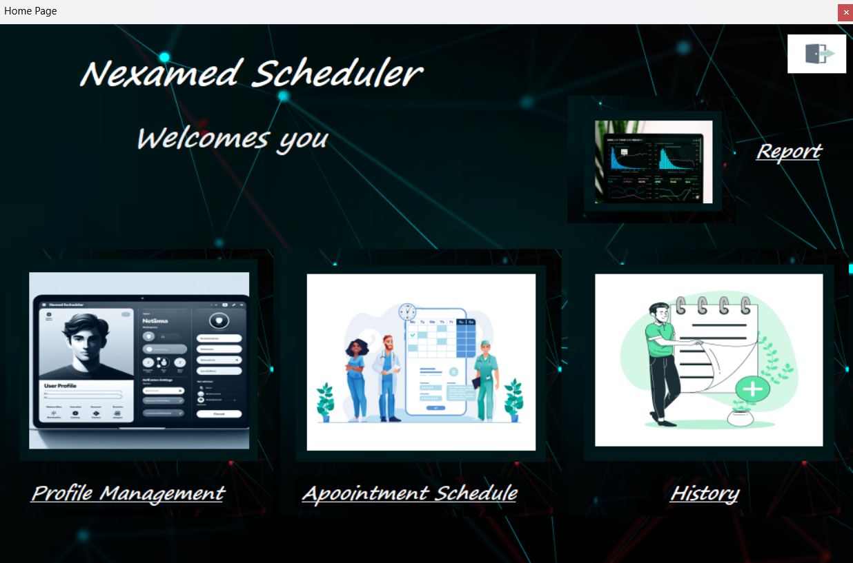

### Admin Page:

### Patient Page:

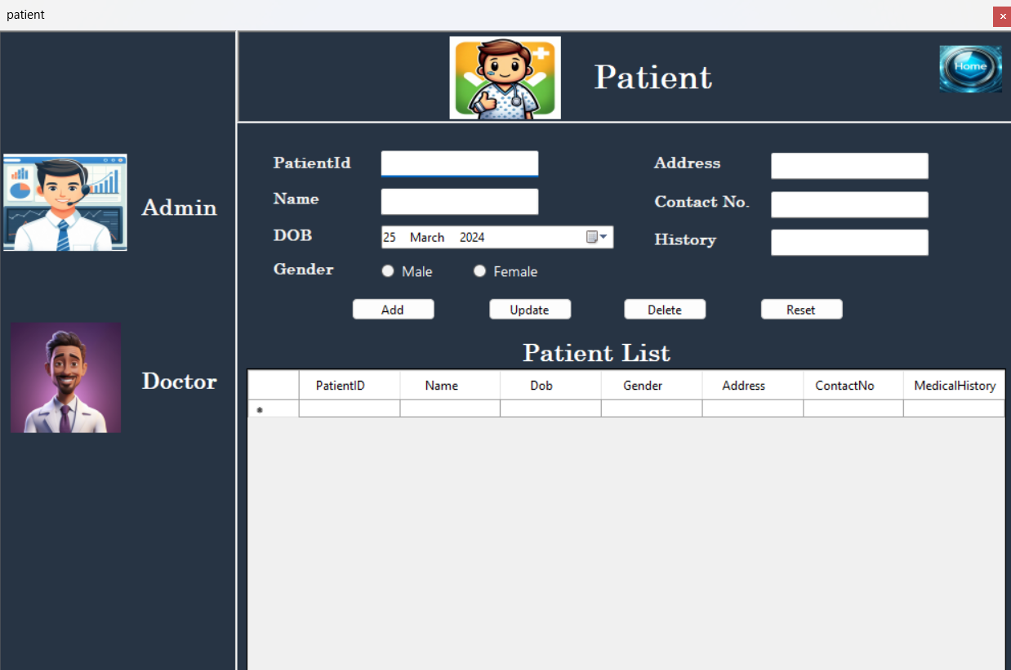

### Doctor Page:

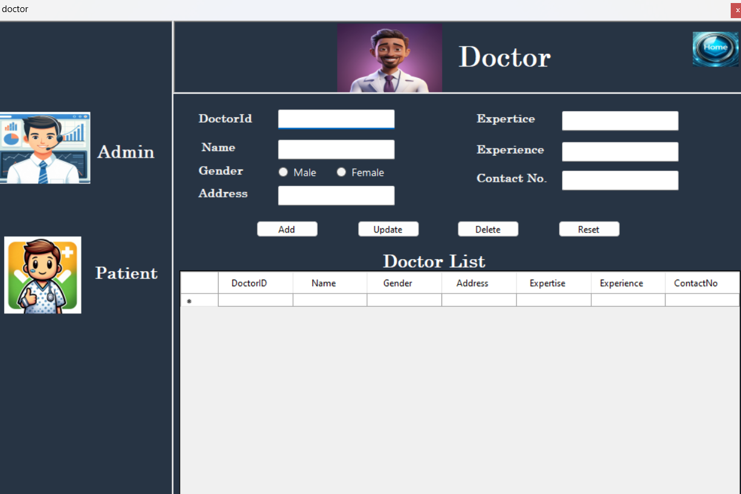

### Appointment Booking Page:

### History Page:

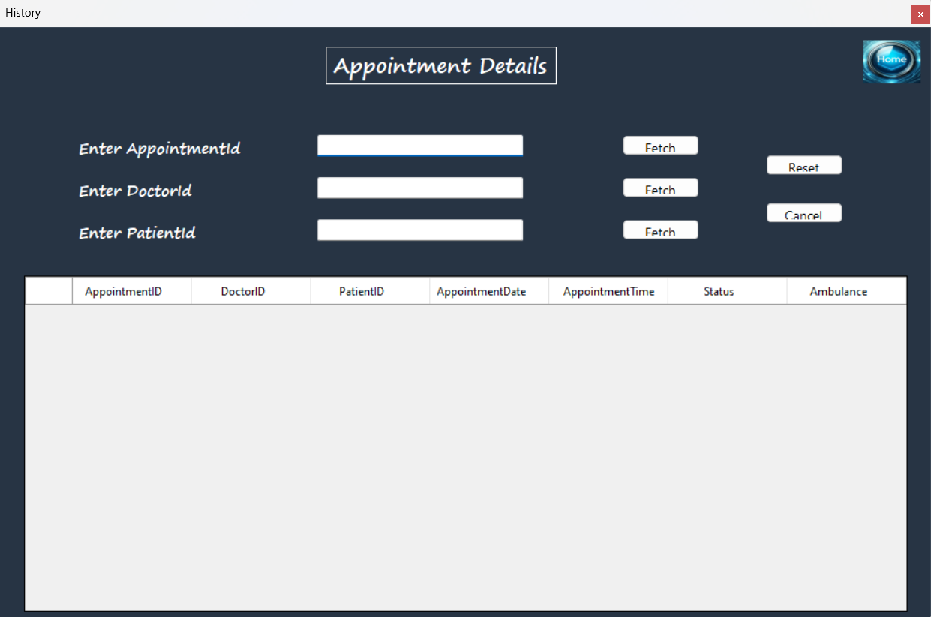

### Report Page:

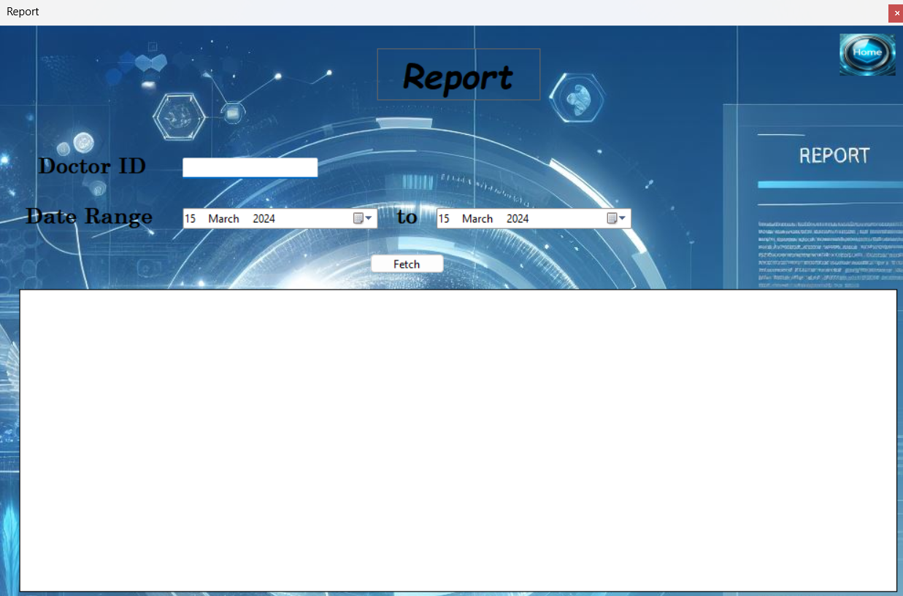

### Register Page:

**CHAPTER 7**

**TESTING**

**7. TESTING**

Software testing is the crucial element of the software quality assurance and represents the ultimate review of specification, design and coding. Testing represents an interesting anomaly for the software. During earlier definitions and development phases, it was attempted to build software from an abstract concept to tangible information. The testing phase is a very important phase since it is in this phase; we make sure that the system will perform the task without any error. Testing is vital to the success of the system and is being done by classifying it in two ways- System Testing and Program Testing. Program Testing involves checking the syntax and logic of the program. This checking resulted in achieving error free programs.

No matter how carefully a programmer designs and plans application, the programs are sure to have a few bugs in them. Errors in the program immediately stop program execution and display an error message if the errors are syntax errors. After debugging one can identify the limitations of this project and hence corrections are made. During the system development, each source code was tested for its level of correctness. Each form was run a number of times in order to ensure that the details are entered correctly and works properly.

**7.1 TEST PLAN**

Testing is the major quality control measure employed during software development. In the project, the first test considered is the unit testing. In this unit testing, each modules of the system are tested separately. This is carried out during programming stage itself. Each module should work satisfactory as regard from the module. After the entire module are checked independently and completed then the integration testing is performed to check whether there is any interface errors. Then those errors are verified and corrected. And also the security test is performed to allow only authorized persons to this system. Finally, the validation testing is performed to validate whether the customer requirements are stratified are not.

**7.2 Testing methodologies**

1. Unit Testing.
2. Output Testing.
3. Black-Box Test

**7.3 Unit Testing:**

Unit testing focuses verification efforts on the smallest unit of software design, the module. This is also known as “Module Testing”. The modules are tested separately. This testing is carried out during programming stage itself. In these testing steps each module is found to be working satisfactorily as regard to the expected output from the module.

This test can be considered as unit test. This has been carried out after the completion of one complete part. The word validation itself says about the nature of the test. Entire controls in the program have been tested in this manner. The limitations, nature and the boundaries are tested during the test. This test makes the work worthy to be developed further.

**7.4 Output Testing:**

After performing the validation testing, the next step is output testing of the proposed system since no system could be useful if it does not produce the required output in the specified format. The output generated or displayed by the system under consideration is testing asking the users about the format required by them. Here, the output is considered into two ways: one is on the screen and the other is printed format. The output format on the screen is found to be correct as the format designed according to the user needs. For the hard copy also, the output comes out as specified by the user. Hence output testing doesn’t result in any connection in the system**.**

**7.5 Integration testing:**

The different modules are integrated as per the system design. The different modules are combined into subsystem and then tested to detect errors. The goal of the integration testing is to see if the modules can be integrated properly. It also involves interface testing.

### CHAPTER 8

### IMPLEMENTATION

### 8. IMPLEMENTATION

Implementation includes all those activities that take place to convert from the old system to the new. The old system consists of manual operations, which is operated in a very different manner from the proposed new system. A proper implementation is essential to provide a reliable system to meet the requirements of the organizations. An improper installation may affect the success of the computerized system.

### IMPLEMENTATION METHODS

There are several methods for handling the implementation and the consequent conversion from the old to the new computerized system. The most secure method for conversion from the old system to the new system is to run the old and new system in parallel. In this approach, a person may operate in the manual older processing system as well as start operating the new computerized system. This method offers high security, because even if there is a flaw in the computerized system, we can depend upon the manual system. However, the cost for maintaining two systems in parallel is very high. This outweighs its benefits. Another commonly method is a direct cut over from the existing manual system to the computerized system. The change may be within a week or within a day. There are no parallel activities. However, there is no remedy in case of a problem. This strategy requires careful planning. A working version of the system can also be implemented in one part of the organization and the personnel will be piloting the system and changes can be made as and when required. But this method is less preferable due to the loss of entirety of the system

### 8.1 IMPLEMENTATION PLAN:

The implementation plan includes a description of all the activities that must occur to implement the new

system and to put it into operation. It identifies the personnel responsible for the activities and prepares a

time chart for implementing the system. The implementation plan consists of the following steps:

* List all files required for implementation
* Identify all data required to build new files during the implementation.
* List all new documents and procedures that go into the new system

The implementation plan should anticipate possible problems and must be able to deal with them. The usual problems may be missing documents; mixed data formats between current and files, errors in data translation, missing data etc.

### POST IMPLEMENTATION REVIEW:

After the system is implemented, a review should be conducted to determine whether the system is meeting expectations and where improvements are needed. System quality, user confidence and operating systems statistics are accessed through such technique event logging, impact evaluation and attitude surveys. The review not only assesses how well the proposed system is designed and implemented, but also is a valuable source of information that can be applied to a critical evaluation of the system.

The reviews are conducted by the operating personals as well as the software developers in order to determine how well the system is working, how it has been accepted and whether adjustments are needed. The review of the system is highly essential to determine the future enhancements required by the system. The system can be considered successful only if information system has met it objectives. The review analyses the opinion of the employees and identifies the attitudes towards the new computerized system. Only when the merits and demerits of the implemented system are known, one can determine what all additional features it requires are. The following are the issues to be considered in the evaluation of the system.

* The change in the cost of operation after the installation of the computerized system.
* The basic change that has been affected after the introduction of the system.
* The improvement in the accuracy of the computations.
* The acceptance of the new system by the staff and the convenience it brought to them.
* The change in the effectiveness caused by the implementation of the new system.

A study of the system has revealed that the employees due to the user friendliness have accepted the system, reduced the number of errors, increased accuracy and decreased cost of operations. The system also pays for efficient and speedy execution of operations compared to the earlier system.

**CHAPTER 9**

**CONCLUSION AND FUTURE ENHANCEMENT**

### 9. CONCLUSION AND FUTURE ENHANCEMENT

The completion of the Nexamed Scheduler project within the allocated time frame marks a triumph in efficiency and user satisfaction. With meticulous attention to detail, every aspect of the system has been crafted to provide a seamless experience akin to a leisurely stroll for the user. By elegantly overcoming the shortcomings of previous systems, the Nexamed Scheduler now stands proudly at the client's location, yielding promising results during its trial run.

Utilizing Microsoft VB.NET as its frontend tool and MySQL Workbench as its backend, the development process was a symphony of meticulous testing and integration. With each module meticulously examined before being seamlessly woven into the fabric of the main system, the Nexamed Scheduler proved its mettle when tested with real data, emerging victorious in fulfilling its identified objectives.

Looking to the future, simplicity reigns supreme in potential enhancements. Automated appointment reminders and mobile optimization offer tantalizing possibilities for further streamlining scheduling processes, while fortifying security measures and soliciting user feedback promise continued refinement. Envisioning beyond, the horizon of enhancements expands, embracing the prospect of online appointment booking and seamless ambulance service coordination. These advancements, like threads woven into a tapestry, aim to not only streamline operations but to elevate the entire user experience, fostering a realm where satisfaction and efficiency converge seamlessly.

In summation, the Nexamed Scheduler System stands as a testament to innovation and excellence, offering a harmonious blend of efficiency and user-centric design. With an unwavering commitment to meeting evolving needs, it embodies a beacon of reliability and sophistication in the realm of security service management.

**CHAPTER 10**

**BIBLIOGRAPHY**

**10. Bibliography**

* Francesco Balena 2002. Programming Microsoft Visual Basic .NET, US: Microsoft Press.
* Anne Boehm 2012. Murach's VB.NET, US: Mike Murach & Associates, Inc.
* Bill Sheldon, Billy Hollis, Rob Windsor, David McCarter, Gastón C. Hillar, Todd Herman 2010.
* Professional Visual Basic 2010 and .NET 4, US: Wiley Publishing, Inc.
* Evangelos Petroutsos 2010. Mastering Microsoft Visual Basic 2010, US: Sybex.
* Deborah Kurata 2013. Doing Objects in Visual Basic 2005, US: Addison-Wesley.

**Websites**

1. https://en.wikipedia.org/wiki/SQL_Server_Management_Studio
2. https://en.wikipedia.org/wiki/Visual_Studio

**CHAPTER 11 APPENDICES A**

### 11. APPENDICES A

A database is an organized mechanism that has the capability of storing information through which a user can retrieve stored information in an effective and efficient manner. The data is the purpose of any database and must be protected.

The database design is a two-level process. In the first step user requirements are gathered together and a database is designed which will meet these requirements as cleanly as possible. This step is called Information Level Design and it is taken independent of any individual DBMS.

In the second step this information level design is transferred in to a design for the specific DBMS that will be used to implement the system in question. This step is called Physical Level Design, concerned with the characteristics of the specific DBMS that will be used. A database design runs parallel with the system design. The organization of the data in the database is aimed to achieve the following two major objectives.

* Data Integrity
* Data Independence

### Tables Structure

### Admin Table:

|  |  |  |  |
| --- | --- | --- | --- |
| **Field name** | **Data type** | **Description** | **Constraints** |
| AdminId | int | Admin unique id | Primary key |
| Password | varchar(50) | password | NOT NULL |

### Doctor Table:

|  |  |  |  |
| --- | --- | --- | --- |
| **Field name** | **Data type** | **Description** | **Constraints** |
| DoctorId | int | Doctor unique id | Foreign Key |
| Name | varchar(50) | Doctor name | Not Null |
| Gender | varchar(50) | Doctor Gender | Not Null |
| Address | varchar(50) | Doctor’s Address | Not Null |
| Expertise | varchar(50) | Doctor’s Expertise | Not Null |
| Experience | int | Doctor’s Experience | Not Null |
| ContactNo | varchar(50) | Doctor’s ContactNo | Not Null |

### Patient Table:

|  |  |  |  |
| --- | --- | --- | --- |
| **Field name** | **Data type** | **Description** | **Constraints** |
| PatientId | int | Patient unique id | Foreign Key |
| Name | varchar(50) | Patient name | Not Null |
| Gender | varchar(50) | Patient’s Gender | Not Null |
| Address | varchar(50) | Patient’s Address | Not Null |
| Dob | Date | Patient’s Expertise | Not Null |
| History | varchar(50) | Patient’s Medical History | Not Null |
| ContactNo | varchar(50) | Patient’s ContactNo | Not Null |

### Appointment Table:

|  |  |  |  |
| --- | --- | --- | --- |
| **Field name** | **Data type** | **Description** | **Constraints** |
| AppointmentId | int | Unique AppointmentId | Primary Key |
| DoctorID | int | Doctorid from doctor table | NOT NULL |
| PatientId | int | PatientId from  Patient table | Foreign Key |
| Appointment  Date | Date | Appointment date | NOT NULL |
| Appointment  Time | varchar(50) | Appointment time | NOT NULL |
| Status | varchar(50) | Status of appointment | NOT NULL |
| Ambulance | varchar(50) | Ambulance required or not | NOT NULL |

**CHAPTER 12 APPENDICES B**

**SCREEN SHOTS**

### 12. SCREENSHOTS

### Login Page

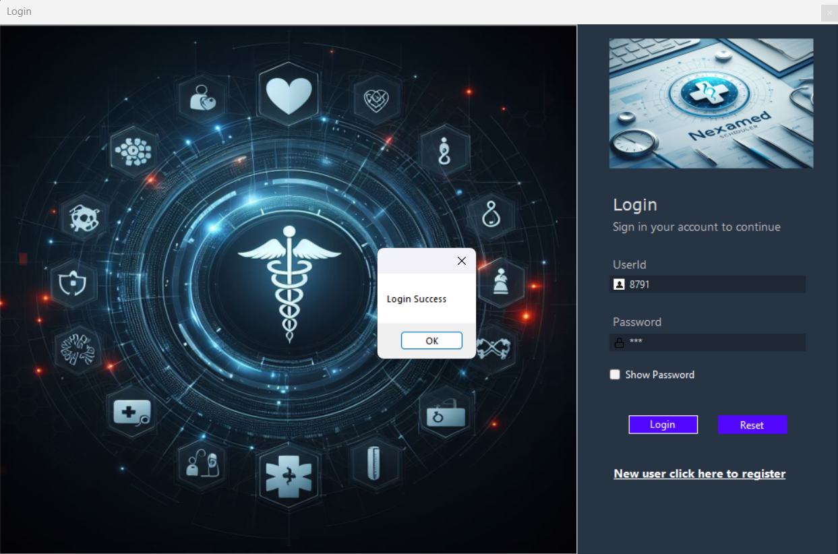

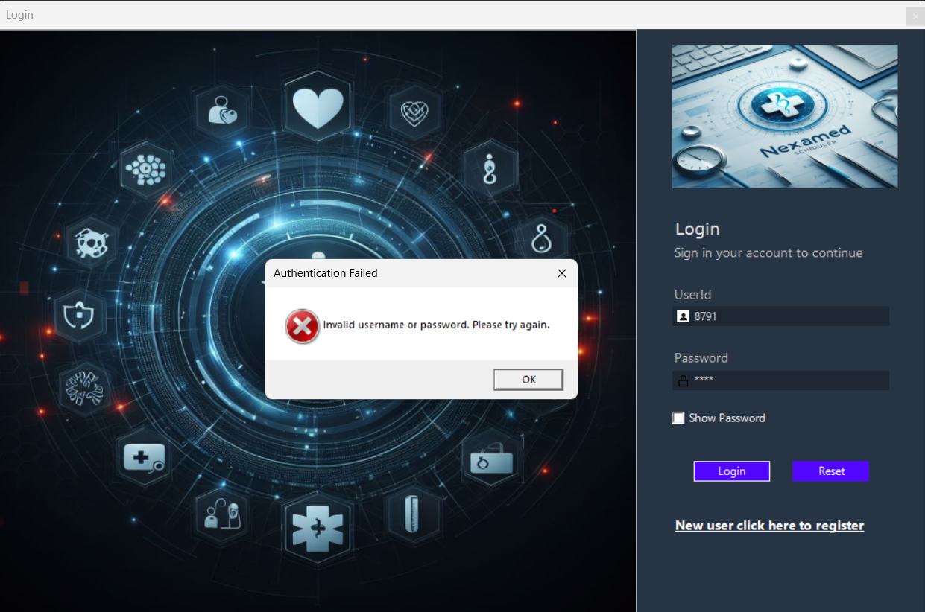

### Doctor Page

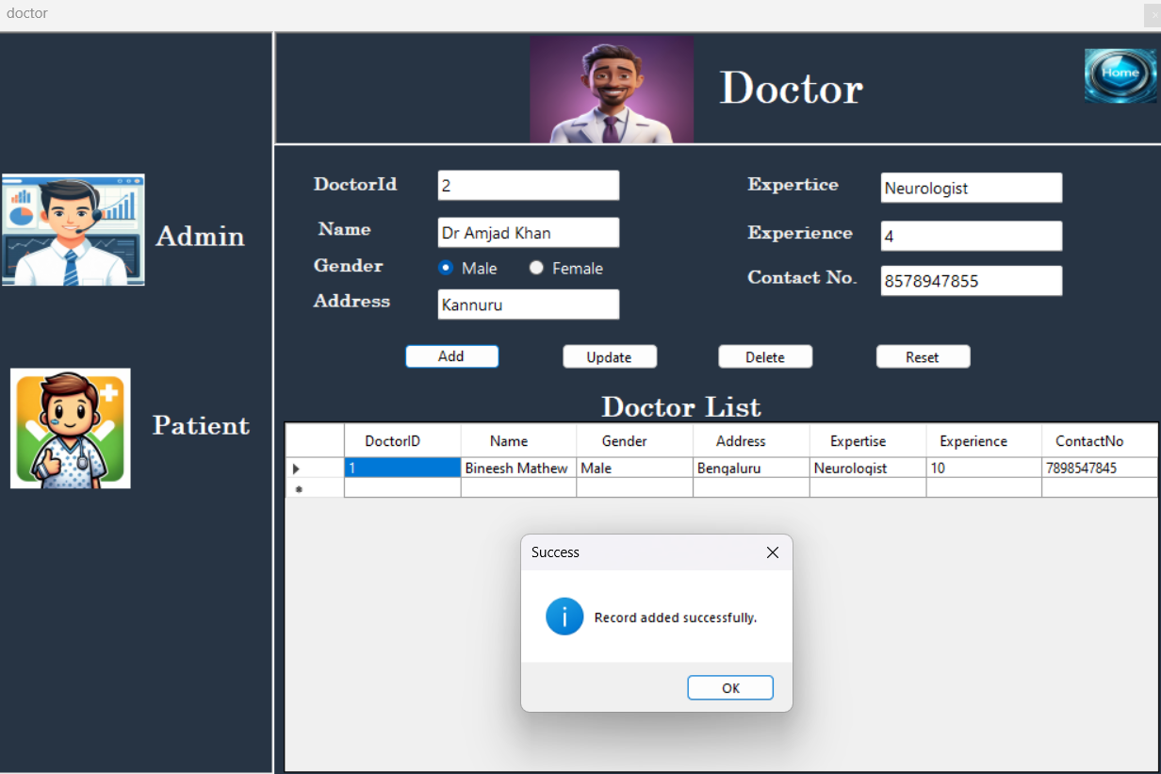

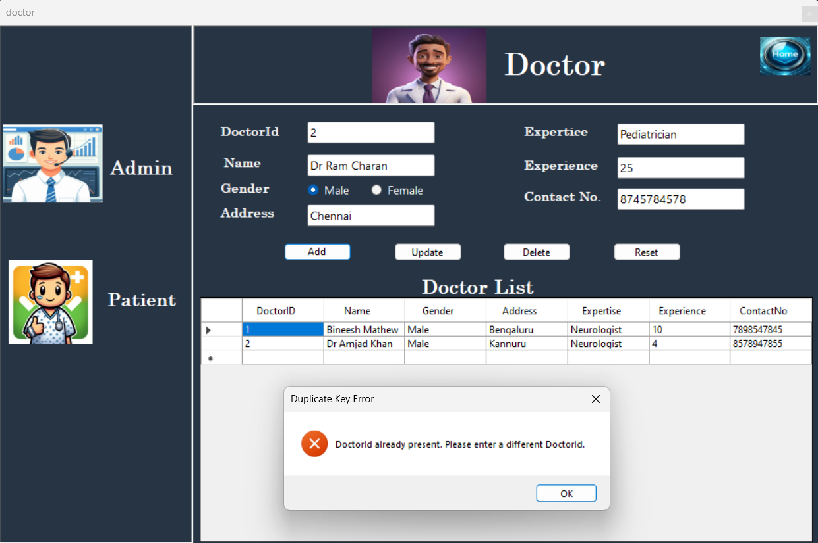

### Patient Page

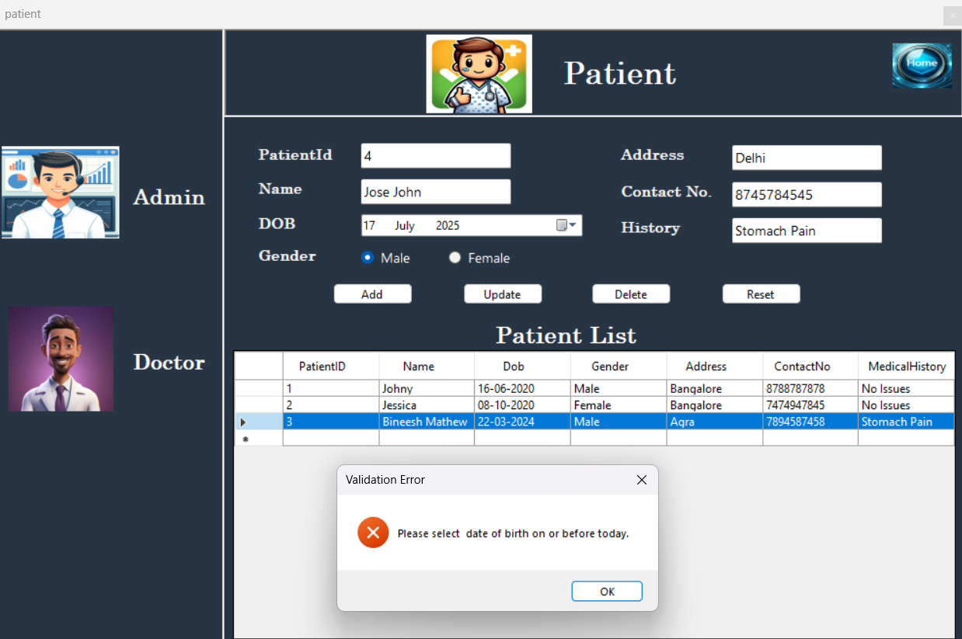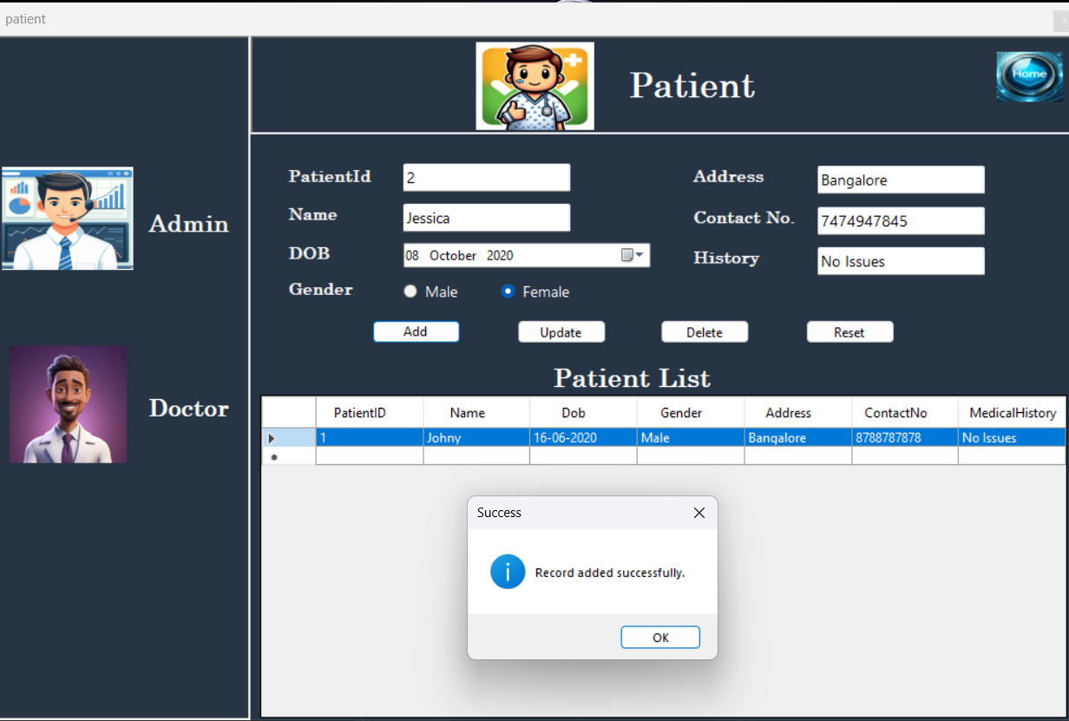

### Appointment Page

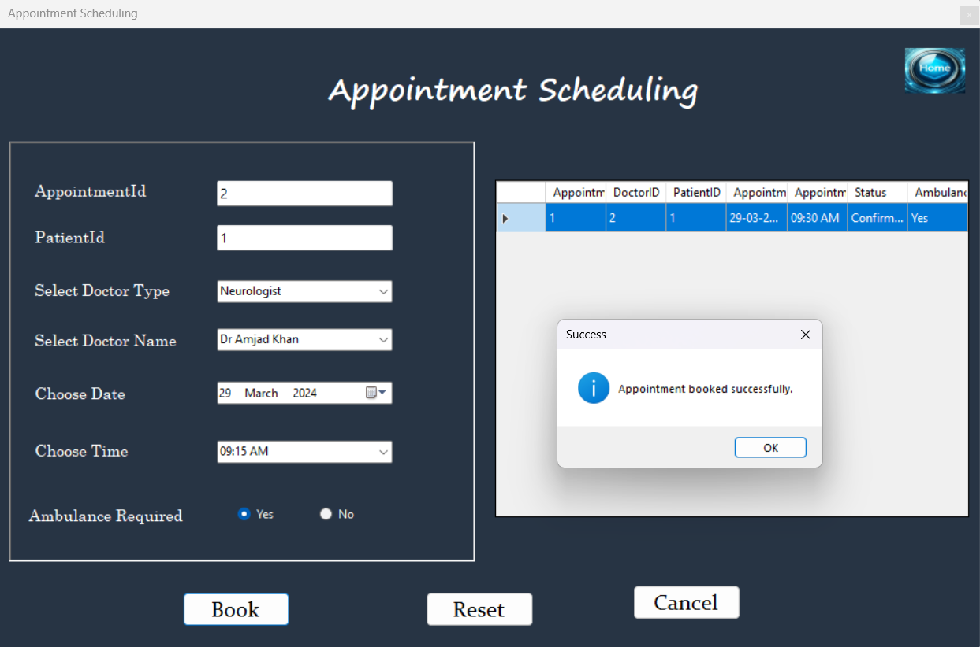

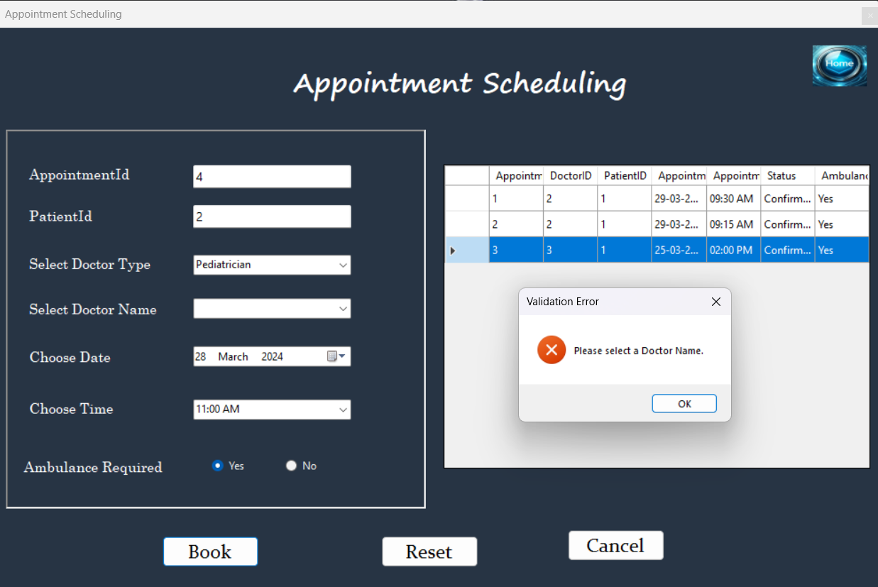

### Registration

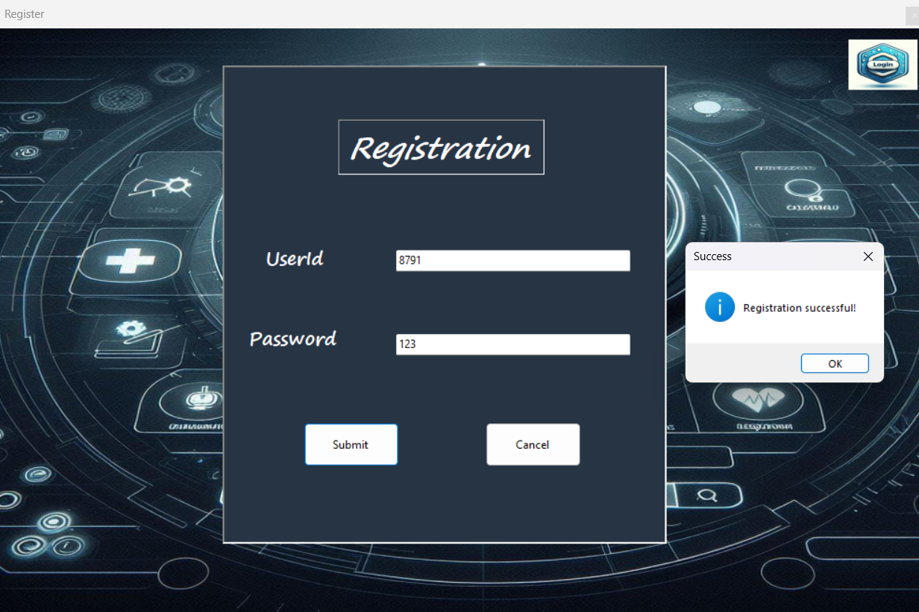

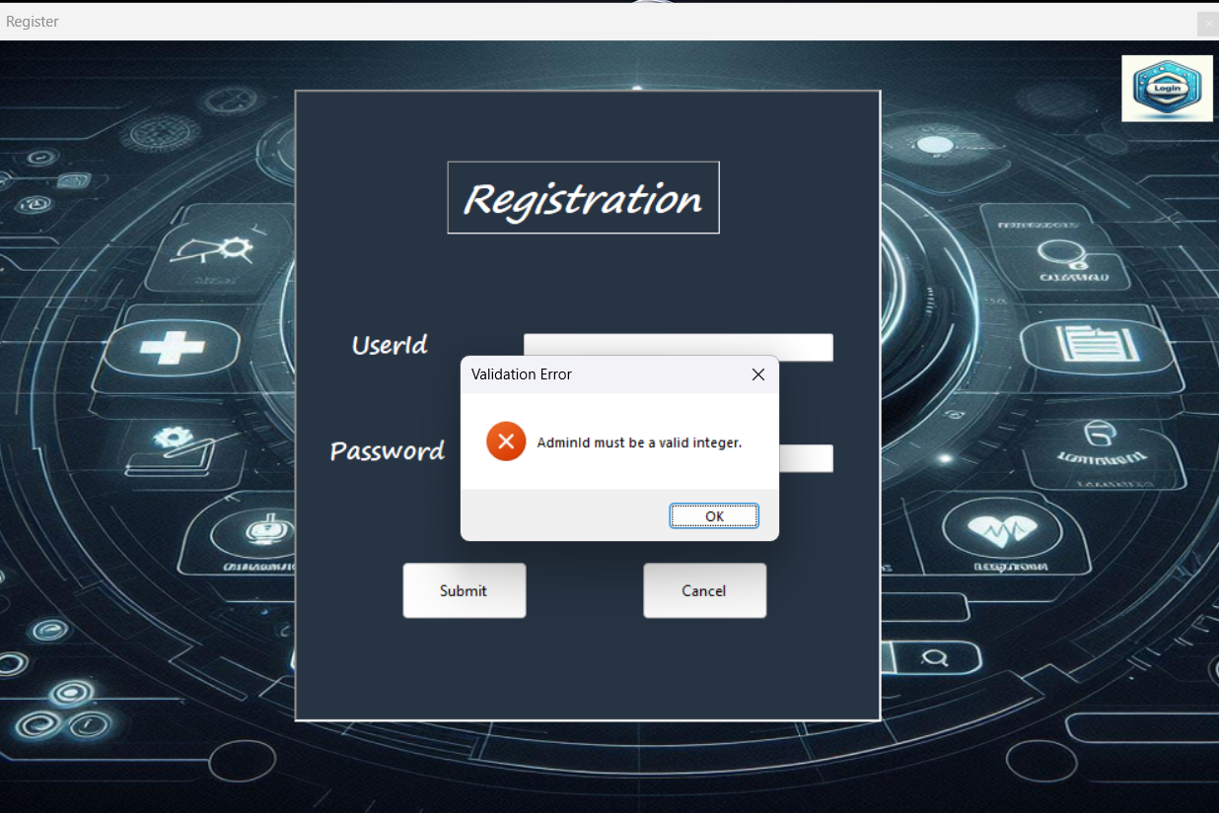

**CHAPTER 13 APPENDICES C**

**SAMPLE REPORTS OF**

**TEST CASES**

### 13. Test cases

|  |  |  |  |  |  |  |  |
| --- | --- | --- | --- | --- | --- | --- | --- |
| Project Name | Nexamed Scheduler | | | | | | |
| Module Name | Login/Profile Management/Appointment Booking/History | | | | | | |
| Test  Reviewed By- | Prof. R Aswin Herbert Sathish | | | | | | |
| Requirements ID | Test Case ID | Test Name | Test  Prerequisites | Form Name | Expected Result | Actual Result | Test Status |
| T1 | TC_1 | Login | Valid Username and Password | Login  Form | Successful Login | Login  Success | Pass |
| T2 | TC_2 | Login  Wrong credentials | Invalid  Username and password | Login Form | Unsuccessful  Login | Invalid  Username or password | Pass |
| T3 | TC_3 | Admin  registration | Valid  Admin  Details | Register  Form | Admin  Registration | Admin registration  Successful | Pass |
| T4 | TC_4 | Admin  Registration  with invalid  userid | Invalid  Userid | Register  Form | Error  Message | Adminid  must be valid  integer | Pass |
| T5 | TC_5 | Doctor registration | Valid  Doctor details | Doctor  Form | Doctor  Registration | Doctor added  successfully | Pass |
| T6 | TC_6 | Doctor  Registration  with invalid  experience | Invalid  Experience | Doctor Form | Error  Message | Experience  must be  numeric value | Pass |
| T7 | TC_7 | Patient  Registration | Valid  Patient  details | Patient  Form | Patient  Registration | Patient added  Successfully | Pass |
| T8 | TC_8 | Patient  Registration  with invalid  Dob | DOB  In  Future | Patient  Form | Error  Message | DOB cannot  be in future | Pass |
| T9 | TC_9 | Appointment Booking | Valid appointment details | Appointment  Form | Appointment booking | Appointment booked successfully | Pass |
| T10 | TC_10 | Appointment booking without selecting a doctor name | Not selected doctor name | Appointment Form | Error Message | Select a doctor  name | Pass |
| T11 | TC_11 | Appointment History | Valid  appointment id | History  Form | Appointment Display | Displayed appointment for particular  Appointment id | Pass |
| T12 | TC_12 | Appointment History  with invalid  appointment  id | Invalid  Appointment id | History  Form | Error Message | No such appointment | Pass |
| T13 | TC_13 | Pressing Add button in admin form | Enter all the details | Admin  Form | Admin  Registration | Admin Registered  Successfully | Pass |
| T14 | TC_14 | Pressing Add button in admin form | Enter only some of the details | Admin  Form | Error Message | Enter both userid and password | Pass |